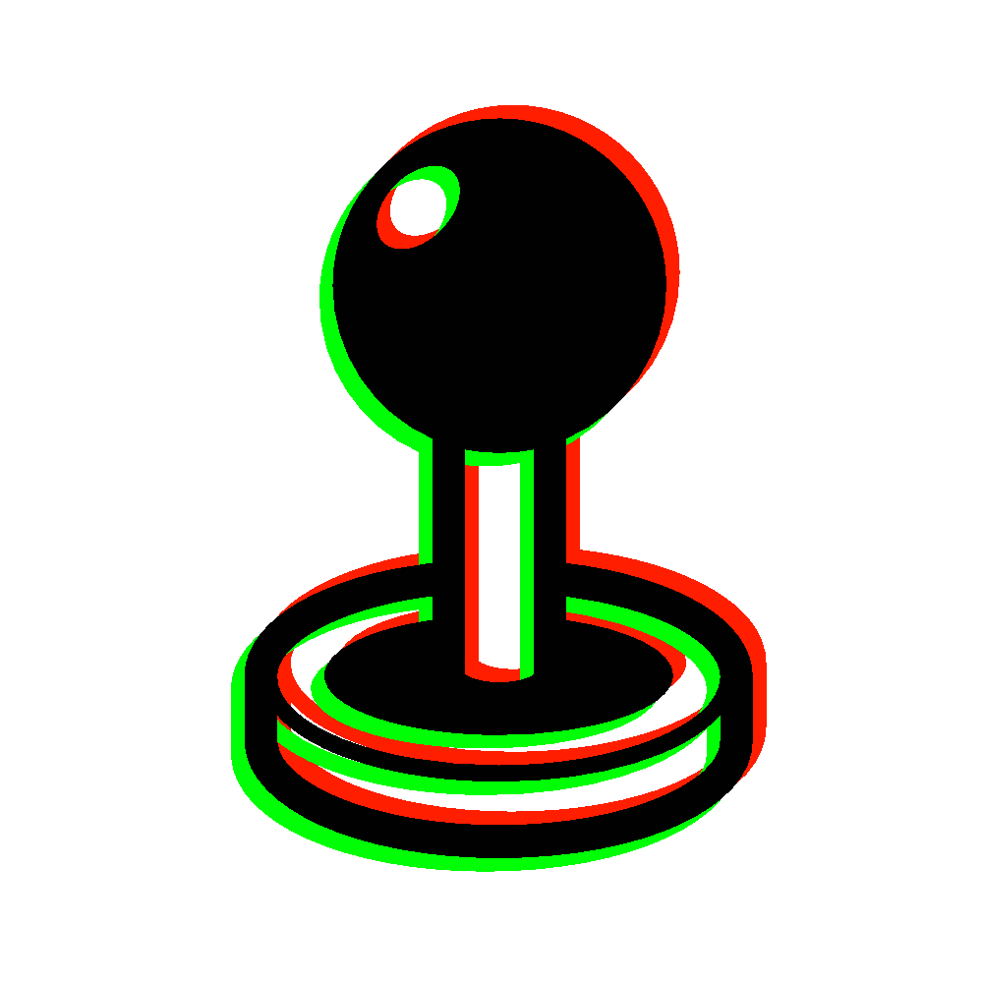

Unit 3: Videogame for VET
Production: Evaluation sheet

Learning Outcome 1 - Transfer the elements of the game design into the production phase. Getting to know the video game editor

Task 1

Make a quick list of the functionalities of the video game editor that you will use for each game element defined in the design phase (characters, scenarios, etc.)

Task 2

Have a look at the edition options and see what can you change right now. Discuss with your mates what have you found out.

Learning Outcome 2 – Identifying, finding and importing the appropriate resources needed to work with

Task 1

Look up some graphical resources on the Internet. Have in hand the asset descriptions that can be found in the documentation of the program.

Task 2

Import the resources with the resource manager or directly in the game folder. See how you can implement (for example: character faces are used in the “actor” tab of the database).

Learning Outcome 3 - Draw the graphic interface of the levels: maps or scenarios

Task 1

Draw a small outdoors map (no more than 40x30 tiles). You can use this map for practising. When drawing, use at least these kinds of tiles: ground, water, walls, roofs. Also, add scenario elements like trees, signs, objects, etc.

Task 2

Follow the requirements of the design phase and focus on your video game story to create at least two new maps. You can use the practice map to test designs.

Task 3

Once you have at least two maps, create a quick event on the events layer that makes your character teleport from one map to another.

Learning Outcome 4 - Create and edit game elements

Task 1

Create at least one character. Choose among the graphic resources you have to create the looks. After that, consider if the character has some skills or habilites and edit them in the “classes” section.

Task 2

Create several items and consider which ones are wearables (in this case: how will they modify the character’s abilities) and what are the non-wearables for (are they healing items, quest rewards, power ups...?).

Task 3

Create an enemy, then a troop and test the battle with your character(s). Change the strenghts and weaknesses of the enemy so it fits into the difficulty level you desire, according to the level you predict the character(s) will have.

Task 4

Enhace the battles by creating skills and assigning them to both your characters and the enemies. Create several troops that have different difficulty levels.

Learning Outcome 5 - Program events and objects

Task 1

Create an NPC and program it so when the player touches the action button, a small conversation starts.

Task 2

Create a chest. It must give the player an item once, so when he tries to look into the chest a second time, it doesn’t give him anything. Create a quick chest event first and see how are the lines displayed. Pay attention to the usage of the switch. After that, place 3 chests around the maps that give the same item (remember: just once each time).

Task 3

Create a new NPC (NPC3) that asks you for 4 units of the item you have placed on the chests in exchange for something else (it can be another item or gold), which will give to you only after you have 4 units of the first item.

To create this event you have to use a variable and add 1 each time you get a unit of the item. You can add this command at the start of the conversation with NPC3. Also, you will need to create a conditional branch command in order to make NPC3 react differently depending on the number of the variable. If it’s 4, then NPC3 should give you the reward. If it’s less than 4, NPC3 should tell you to keep on collecting items.

Task 4

Create a cutscene for the beginning of the videogame and another for the ending. Each of those can be dialogues, there can be a narrator, they might have action with animations and movements, etc.

ERASMUS PLUS KA2 STRATEGIC PARTNERSHIPS
Vocational Education and Training

Grant Agreement No. 2015-1-ES01-KA202-016010

