CO-Game - I01. Civic Heritage Descriptor
The Mundaneum in Belgium

- Historical context of the heritage object

Political trends

- In Belgium, reigns of Leopold II (1865 - 1909) and Albert I (1909 – 1934)
- Peace Congress at The Hague (1899) and creation of the International Peace Bureau (1891)
- First World War (1914 - 1918)
- Creation of the League of Nations (1919)
- Universal male suffrage in Belgium (1921)
- Creation of the United Nations (1944)

Economic Trends

- The industrial revolution in Belgium (c. 1798 – c. 1847)

Social Trends

- Internationalism
- Pacifism
- Feminism

Cultural and scientific trends

- Esperanto (1887)
- World Exhibitions in Paris (1900) and Brussels (1910)
- Development of transport and communication
- Modernism in art and architecture

- Presentation of the heritage object
- Who

- Which person or institution has founded / created the heritage object?
The Mundaneum was founded by Paul Otlet (1868 - 1944), pioneer of modern information science, and Henri La Fontaine (1854 - 1943), Nobel Peace Prize in 1913.

- What was their role in society at that time?
Paul Otlet and Henri La Fontaine both studied law. At the time of the creation of the Mundaneum, Paul Otlet was an intern at a law firm in Brussels and Henri La Fontaine was Secretary in the same law firm.
Later, Henri La Fontaine became senator in the Belgian Workers Party and lawyer of international law. Paul Otlet devoted his career and his life to the development of the Mundaneum, bibliography, the science of books and documentation, communication tools, museography...

- What did they look like?

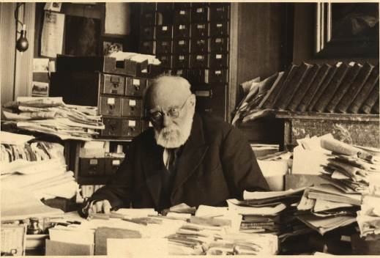 Paul Otlet
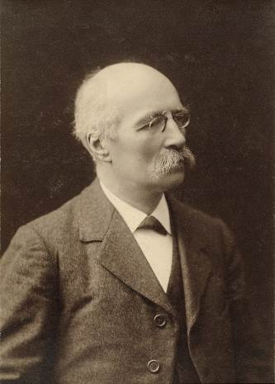 Henri La Fontaine

- When

- When was the heritage object created?
In 1895 (late 19th Century)

- Who held political power at that time?
Belgium being a kingdom, the country was ruled by King Leopold II (1865 - 1909) followed by Albert I (1909-1934) (see Wikipedia for a description of the two kings)

- Did the political power support the creation of the heritage object?
The Belgian government was responsible for the expansion and decay of Mundaneum.
In 1910, the Belgian government will lend to PO and HLF rooms at the Cinquantenaire (Brussels) in order to install the International Museum.
In 1920, more than 100 rooms will be loaned by the government to develop the Mundaneum.
In 1934, it will be the same government that will close the Mundaneum.

- Where

- Where was the heritage object created?
In Brussels (mainly at the Jubilee Park from 1910).

- Is it a strategic location enabling the development of a political, economic strategy...?
Brussels is Belgium’s capital and the Jubilee Park was one of its most prestigious monuments.
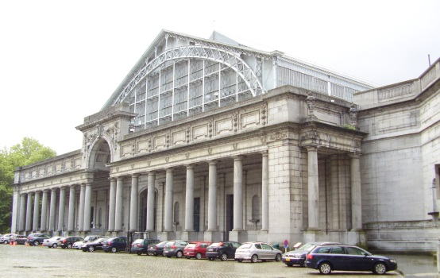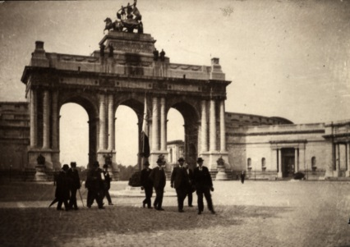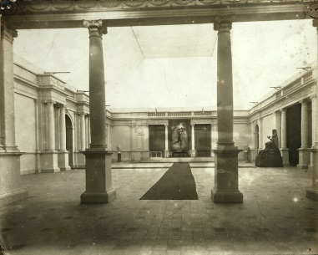
The Jubilee Park buildings devoted to the Mundaneum between 1910-1944.

- Is the heritage object part of a specific heritage site?
The heritage site is a symbolic one because it commemorates the fiftieth anniversary of the 1830 revolution that led to the independence of Belgium. This monument represents Belgium, right into the economic and industrial growth.
- Is this site an integral part of the heritage object?
The heritage object existed long before its installation in the aforementioned heritage space. One and the other are independent. After the closing of the Mundaneum doors in 1934 at the Jubilee Park, the heritage object continued to exist.

- Has the heritage site undergone changes since its creation?
The heritage space (the Jubilee Park / le Cinquantenaire) in which the Mundaneum was installed in 1910, has not changed since its creation.
The Mundaneum has moved several times since the 1940s, being alternately located in the Leopold Park, the Rogier Metro and to finaly in Mons, in an old shop called the Independence (founded in 1920).
The Mundaneum is installed in Mons since 1993. Since the building underwent changes in terms of building spaces, those have been expanded to enable the accommodation of all of our archives and allow a better reception of the visitors.

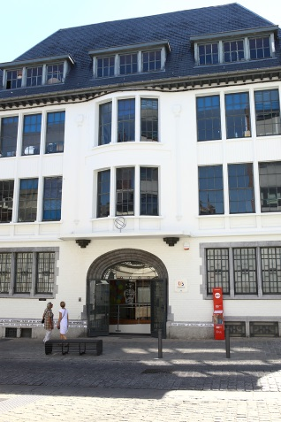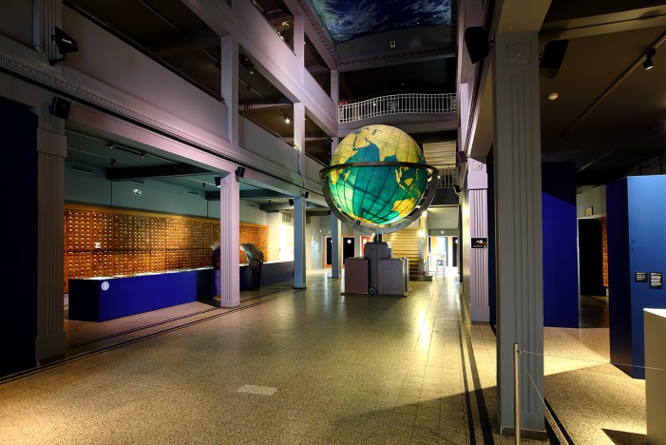
The Mundaneum in Mons

- How is the heritage site used today?
The former store in which the Mundaneum was implanted is used today as a space for temporary exhibitions allowing the highlighting of the preserved archives.

- Has the heritage site the same function today as at its creation?
The space in which the Mundaneum is installed was a former department store called "The Independence". This one was established in the 1930s.

- Why

- What was the goal of the heritage object / the founders?
The project then aimed at collecting and indexing all the knowledge of the world. The Mundaneum became a documentation center with universal character and was during the first half of the 20th century the cradle of humanist international institutions dedicated to the knowledge and to the universal brotherhood.

- Which values inspired the creators of the heritage object?
The founders of the Mundaneum were driven by their involvement in several civic causes of their time: social equity, feminism, internationalism, pacifism. Their project about knowledge was also one of humanistic values.
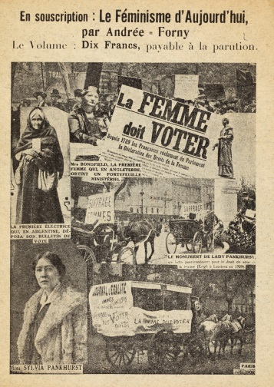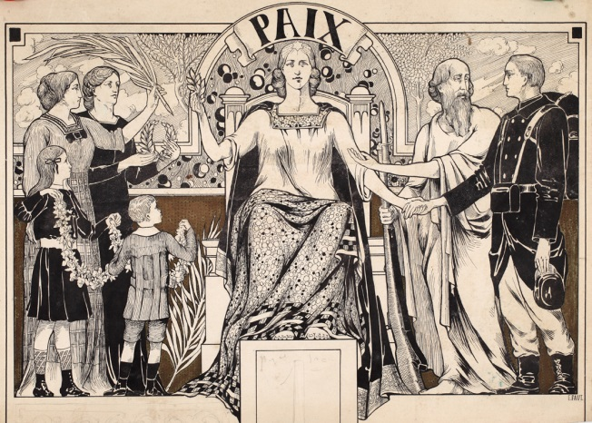

- Was the heritage object part of a European or international movement
The Mundaneum was from the start at the heart of a network devoted to international cooperation. The founders created or took part in several European and international associations embodying their humanistic values. The systems developed by Otlet and La Fontaine were meant to be translated from the start. They also promoted them during international exhibitions and congresses.

- Today

- Today, what has the heritage object become?
The Mundaneum was located in the Jubilee Park until the 1940s but is now an archives centre of the Federation Wallonia-Brussels in Mons. It curates temporary exhibitions to promote the heritage (both physical and philosophical) of its founders.

- Is it still representing the same values ​​as before?
Yesterday’s values stay exactly the same today: to promote pacifism, feminism, to value the knowledge and make it circulate, to sensitize the visitors with diverse societal themes,…

- How is it presented today?
The Mundaneum is now an archives centre of the Federation Wallonia-Brussels and a space for temporary exhibition. It preserves some 6 linear km of documents. Besides the personal papers of the founders, and the collections of newspapers, posters, postcards, photographic glass plates and small documents collected by them or their successors, the Mundaneum preserves archives relative to three main themes: pacifism, anarchism and feminism. The Mundaneum has for objectives the protection and the preservation of these collections, as well as their valuation through exhibitions, through publications and through events such as colloquiums, conferences.

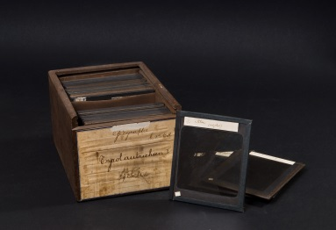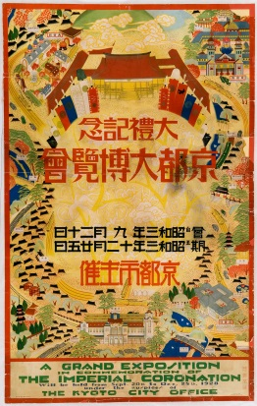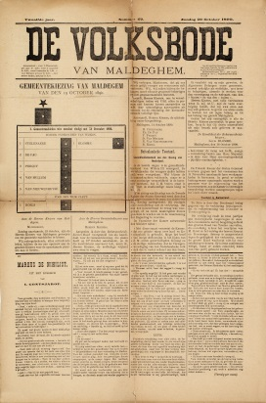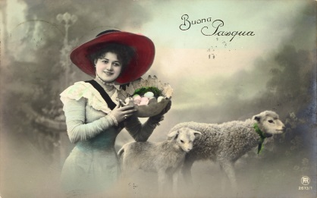
A few examples of the diversity of documents

- Is the information left from the past still relevant?
Both the archives collected by the founders and the values they wanted to promote (peace, knowledge, social and intellectual progress) are still relevant. The Mundaneum project is on the agenda more than ever as a pioneer of information science and a precursor of the information society. Paul Otlet has been recognized as the father of the concept of internet.

- Sets - atmosphere - character

- How were people dressed at the time?
Men wore suits; women wore dresses (they became simpler with time). Everyone wore hats when outside.
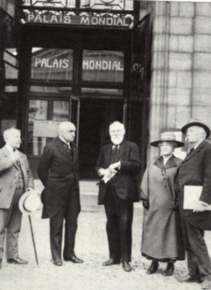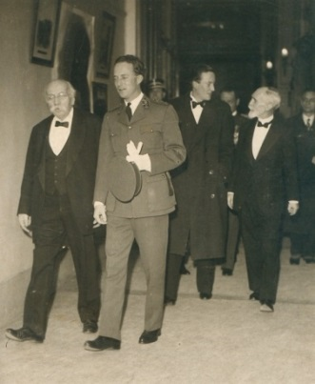

- What were the means of transportation at the time?
The train, the tramway, horses and carts, then the automobile, the bus.

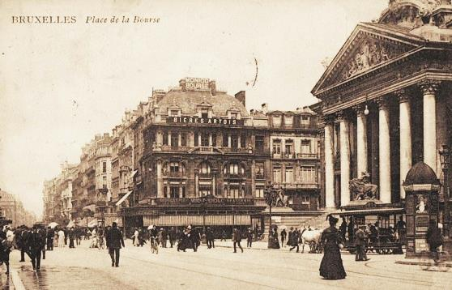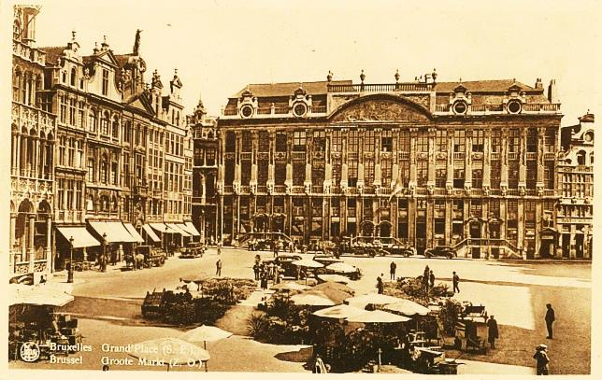
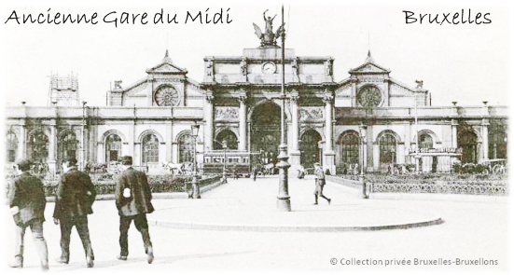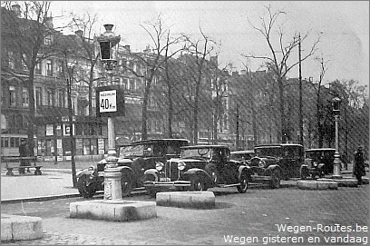

- What were the methods of communication at the time?

The telephone, the phono record, the camera, the (early) television…
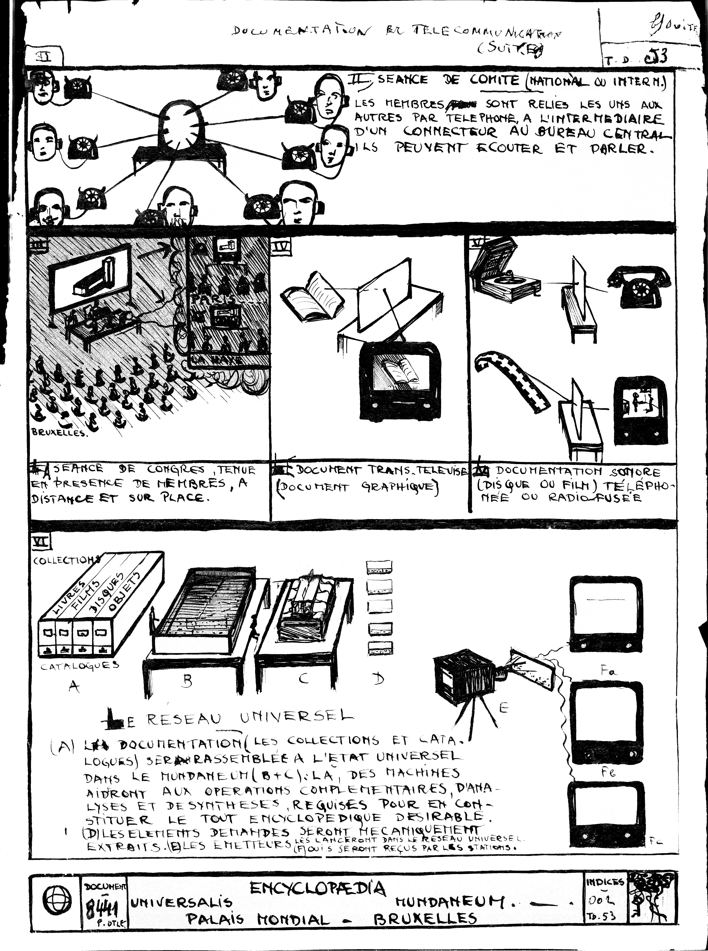
Schematics by Paul Otlet, c.1930
- Themes and Concepts
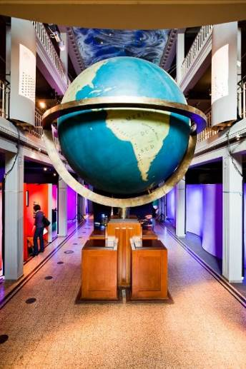
- The sphere
Themes: the knowledge’s world Network / universal Pacifism
Meaning: gathering the whole world knowledge in a single place with a pacifist goal. The aim of Paul Otlet and Henri La Fontaine was to gather together the whole universal knowledge in a single place, in order to facilitate its access. They believed if people knew of each other, they would not fight anymore.
Aims :
- To explain the objectives of Paul Otlet and Henri La Fontaine
- To reflect the concepts of pacifism and knowledge network

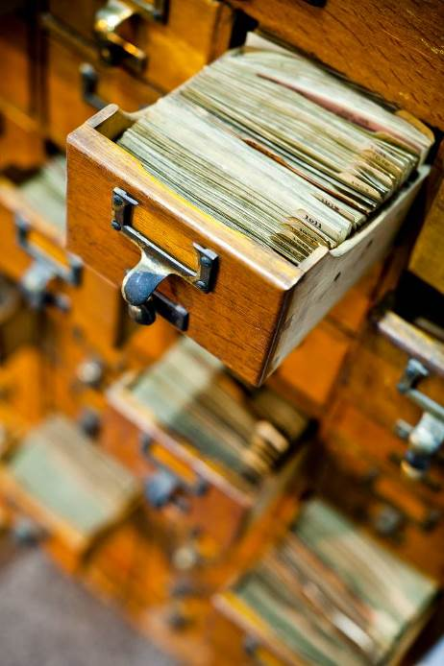
- The Universal Bibliographic Directory (RBU) / the filing cabinets
Recognized by the Unesco’s "Memory of the World” register
Themes: 1st search engine of information / Google of paper
Meaning: the RBU is a tool which informs about the publications of all times, of all countries and relative to all the subjects, hence its universal character. Its general organization allows to answer two essential questions: "what are the works written by such author? " and " What was written on such topics ? ".
The elaboration of such a work required the development of standards, both at the level of the bibliographical index cards and of their classification in furniture files. About 18 million index cards were drafted, classified and exchanged between 1895 and the end of 1930s.
Aims :
- To explain how the RBU is the 1st information’ search engine of history of a technical point of view (invention of the concept)
- To show the concept of the information’s first dematerialization

- The Universal Decimal Classification (CDU)
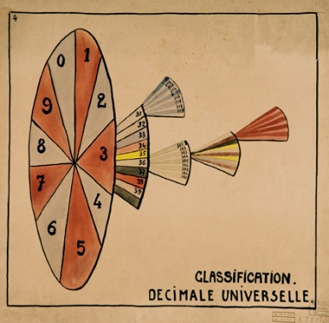
Themes: Universal Decimal Classification
Meaning: the Universal Decimal Classification (CDU) is the language with which the cards of the RBU are organized. Indeed, the bibliographical index cards of the RBU by authors are classified according to the alphabetical order of authors' names but for the Directory by subject matters, they are classified according to the category. These terms must be also translated in the various languages, what deny the universal character for this classification.
The principle of the CDU is simple: all the human knowledge is distributed in 10 classes to which we attribute digits from 0 to 9. Every class is divided into 10 groups, every group contains 10 divisions and every division, 10 subdivisions.
Aims :
- To make the functioning of the Universal Decimal Classification understood and how this system is the first step towards the virtualization of the information (digital language : system of 1/0, bits, bytes)
- To indicate that this system of universal decimal classification was used in a global way and regulate the system of classification in libraries today.

- The ceiling : planisphere / the information highways
Themes: the information highways / Information worldwide network / The premises of the internet
Meaning: the ceiling represents a planisphere covered with clouds. The bright points and the lines represent cities connected between them by information highways.
This scenography represents the futuristic world imagined by Paul Otlet in terms of interconnection and ceaseless flow of the data which travel the world. He anticipated the concept of "internet" network.
Aims:
- To help understand that Paul Otlet anticipated the arrival of Internet and that he was recognized as the father of the concept.

- Bibliography and webography
- Mundaneum : Archives of Knowledge, Occasional Papers n°215, Graduate School of Library and Information Science, University of Illinois at Urbana-Champaign, mai 2010.
- www.mundaneum.org
- https://fr.wikipedia.org/wiki/Mundaneum
- https://www.youtube.com/user/LeMundaneum
- https://fr.wikipedia.org/wiki/Paul_Otlet
- https://fr.wikipedia.org/wiki/Henri_La_Fontaine
- Visuals from the Mundaneum can be found on :
https://commons.wikimedia.org/wiki/Category:Mundaneum
http://digitalarchives.mundaneum.org/browse
http://archives.mundaneum.org/en/collection

- Glossary
Bibliography: the study of the history of books in terms of their classification, printing and publication.
To index: to inventory, to classify, to arrange elements in a specific order.
Pacifism: the idea that conflicts (especially between countries) should be settled without violence.
Feminism: a social theory or political movement which promotes equality of both sexes in all aspects of public and private life.
Anarchism: a political and philosophical belief that all forms of government are unnecessary and that society could function without a ruler or involuntary government (a state).

