Foreword - Curriculum Development for EULER Barcelona
- SESSIONS
Session | 1
Date | 04/10/2016
Duration | 2h
Title | Introduction to a sociocultural reality
Objectives
Contents | - Framework (community cultural formation, co-creation, collaborative work, community art, autoethnografy, visual thinking)  - The sociocultural work in the Barcelona's neighbourhoods (presentation of Carmen de la Flor, Trànsit Projects)  - Visual Map - The triangle's project (experiences, perspectives and future)
Further information | http://www.eulerproject.eu/2016/10/19/comenca-som-la-marina/  http://www.eulerproject.eu/2016/10/26/som-la-marina-vivencies-mirades-i-futur/

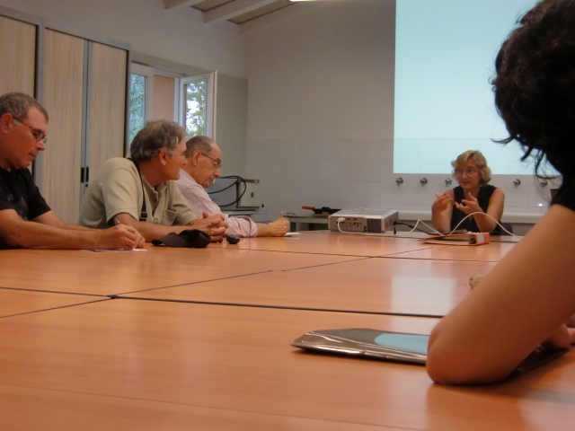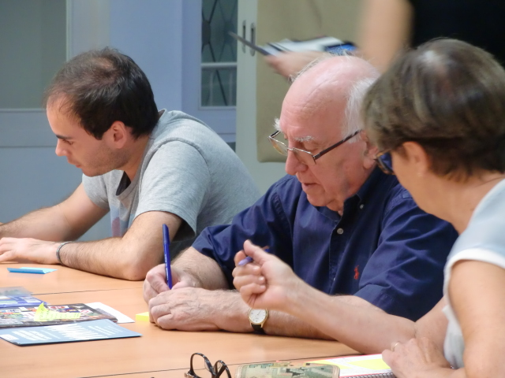
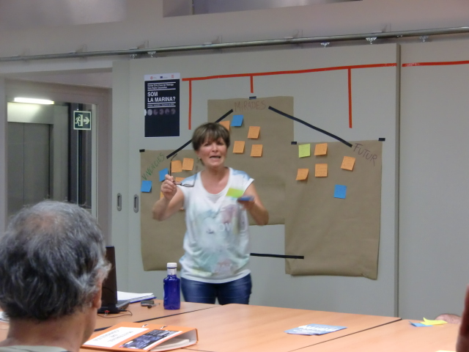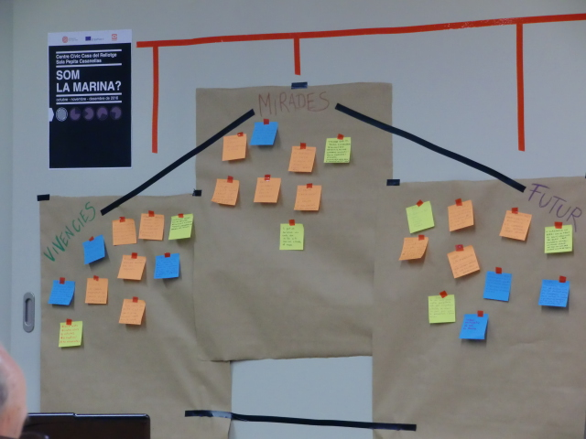

Session | 2
Date | 11/10/2016
Duration | 2h
Title | The identity of the neighborhood
Objectives
Contents | - Memory and heritage.  - The community.  - The identity of La Marina (in charge of Julio Baños, son and chronicler of the neighborhood)
Further information | http://www.eulerproject.eu/2016/10/19/comenca-som-la-marina/  http://www.eulerproject.eu/2016/10/26/som-la-marina-vivencies-mirades-i-futur/

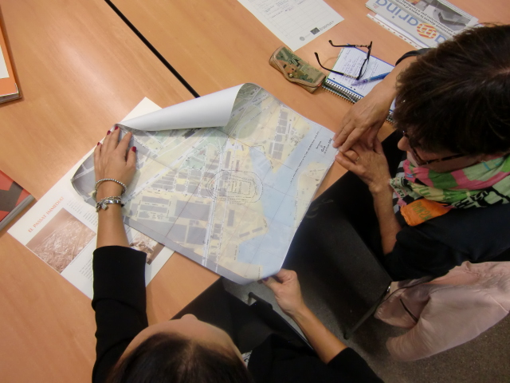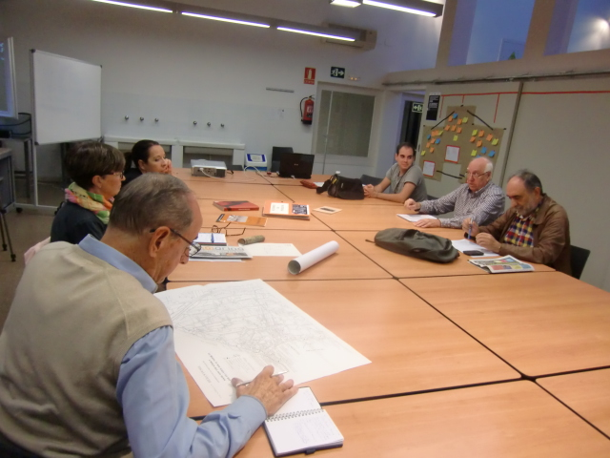
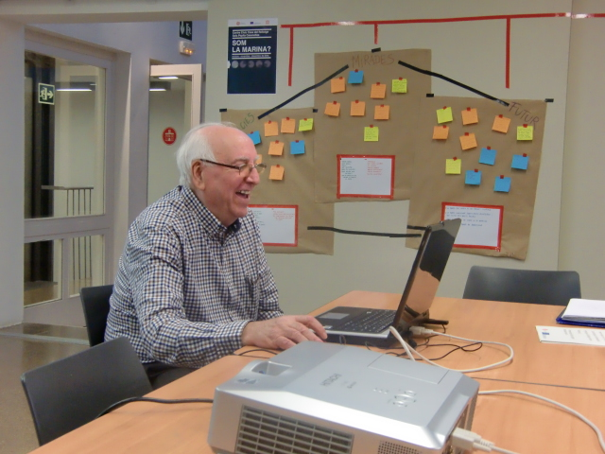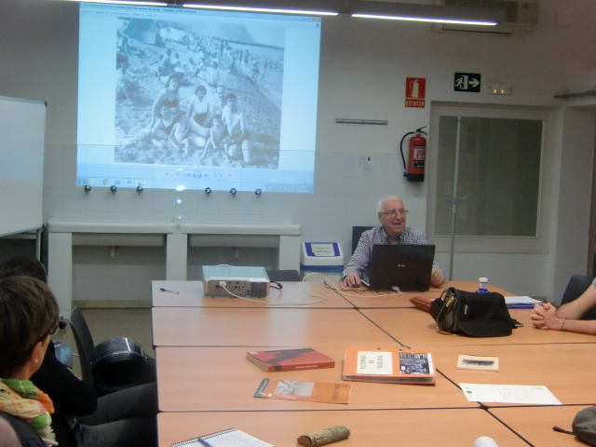

Session | 3
Date | 18/10/2016
Duration | 2h
Title | Our map of La Marina
Objectives
Contents | - Collective cartography - (with the participation of the Association of Artists Marina-Montjuic)
Further information | http://www.eulerproject.eu/2016/10/19/comenca-som-la-marina/  http://www.eulerproject.eu/2016/10/26/som-la-marina-vivencies-mirades-i-futur/

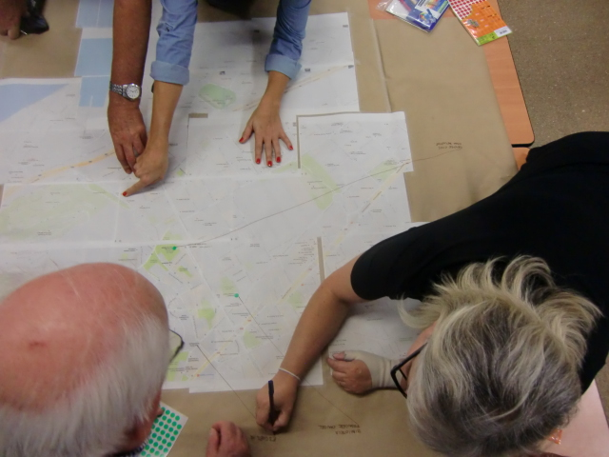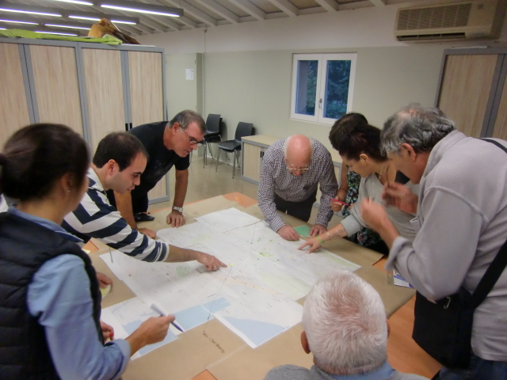
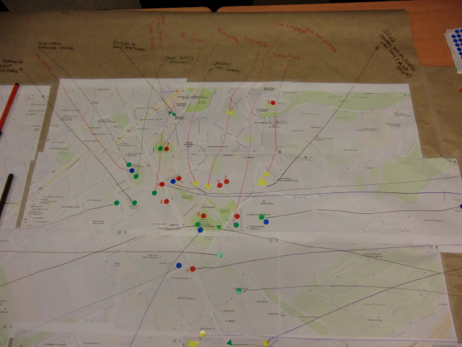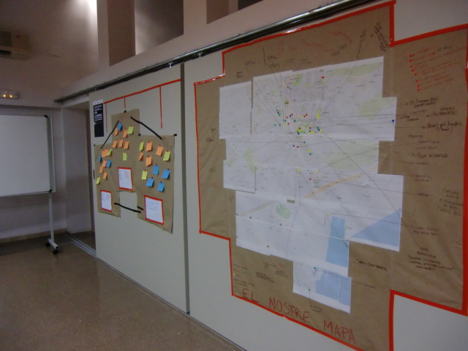

Session | 4
Date | 04/11/2016
Duration | 4h
Title | Personal stories and micro narratives
Objectives
Contents | - Itinerary through the neighborhood of La Marina, focused on participants personal stories
Further information | http://www.eulerproject.eu/2016/10/26/som-la-marina-activitats-novembre/ http://www.eulerproject.eu/2016/12/12/som-la-marina-rutes-memoria-i-territori/

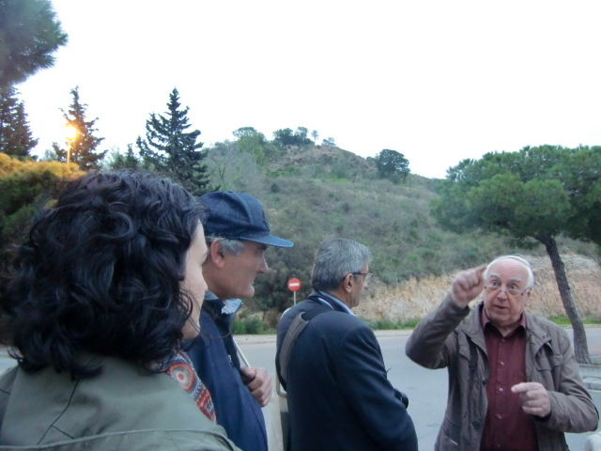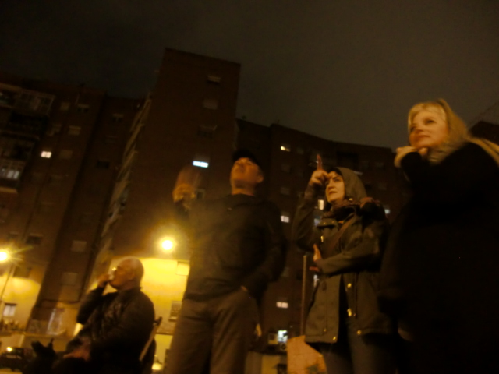
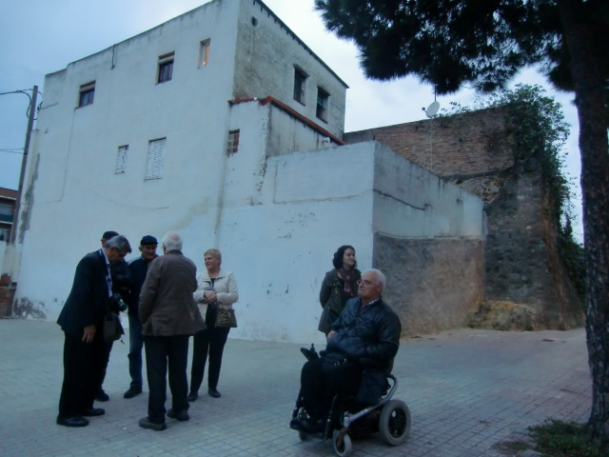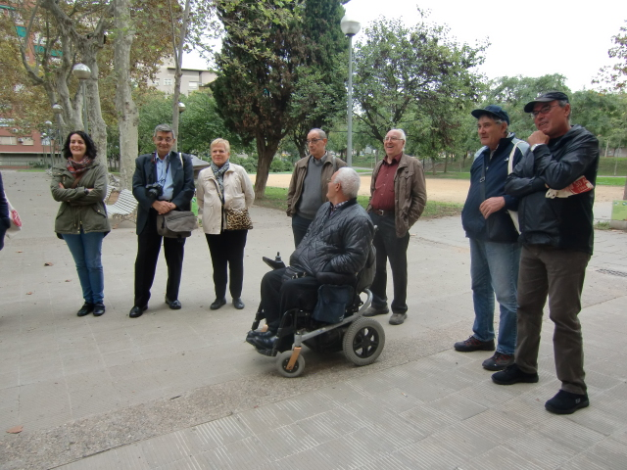

Session | 5
Date | 08/11/2016
Duration | 2h
Title | Visual Culture and Identity. Discovering other experiences.
Objectives
Contents | - Presentation of the project 'Bellvitge rol in vivo' by La Fundició (Mariló Fernandez)  - Presentation of the project 'Capturing Identities' by Escola Cinema Popular de Barcelona (Alberto Bougleux)
Further information | http://www.eulerproject.eu/2016/10/26/som-la-marina-activitats-novembre/ http://www.eulerproject.eu/2016/12/12/som-la-marina-rutes-memoria-i-territori/

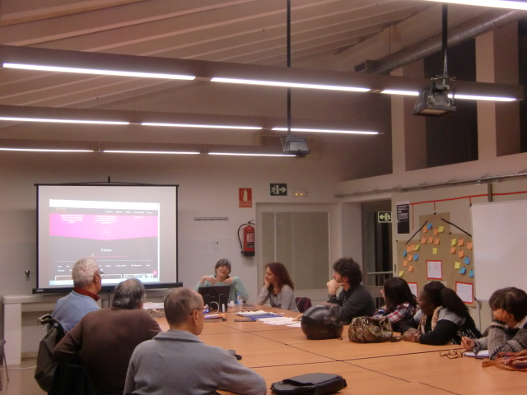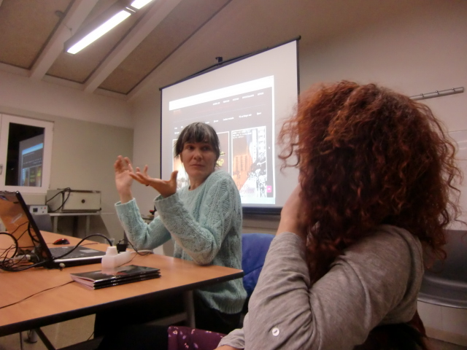
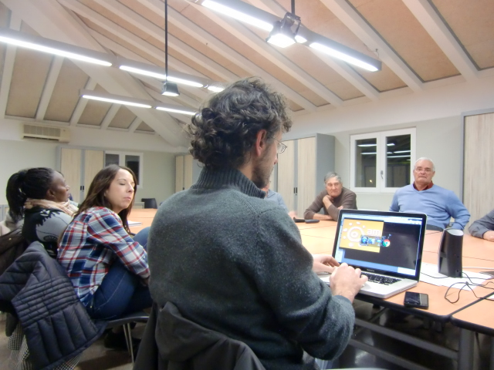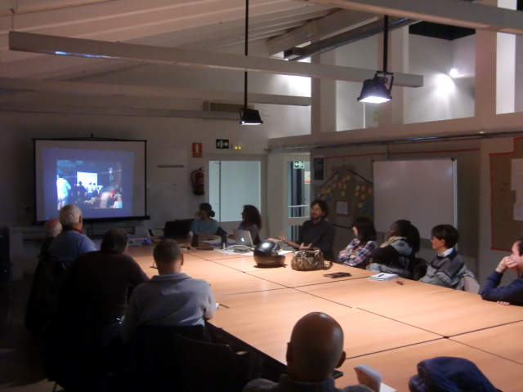

Session | 6
Date | 15/11/2016
Duration | 2h
Title | Images and Videos. How to work with?
Objectives
Contents | - Introduction to the Visual Culture. How to work with images? (by the Photography Club of Casa del Rellotge)  - Introduction to participatory video. How to build a script? (In charge of Escola Cinema Popular de Barcelona, Alberto Bougleux)
Further information | http://www.eulerproject.eu/2016/10/26/som-la-marina-activitats-novembre/ http://www.eulerproject.eu/2016/12/12/som-la-marina-rutes-memoria-i-territori/

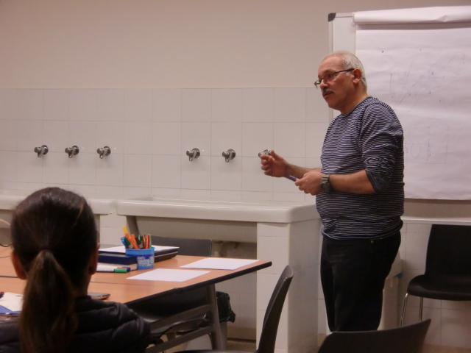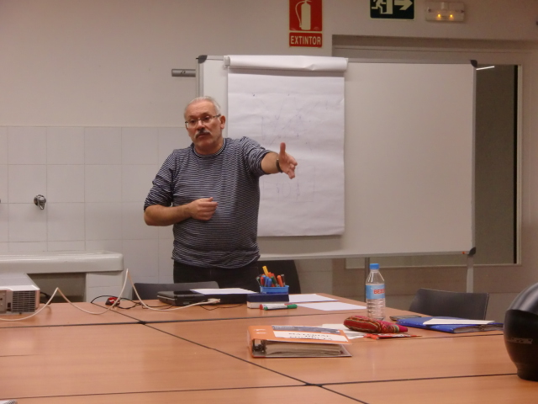
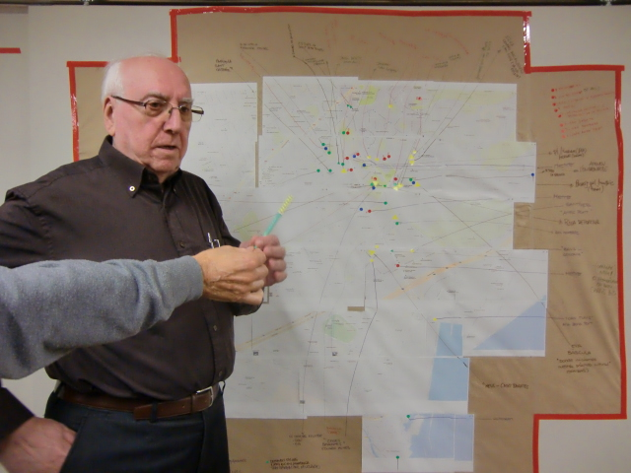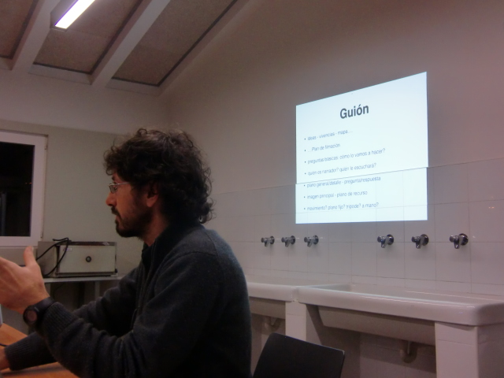

Session | 7
Date | 22/11/2016
Duration | 2h
Title | Communitary television
Objectives
Contents | - Presentation of the project Desdelamina.tv by David Picó
Further information | http://www.eulerproject.eu/2016/10/26/som-la-marina-activitats-novembre/ http://www.eulerproject.eu/2016/12/12/som-la-marina-rutes-memoria-i-territori/

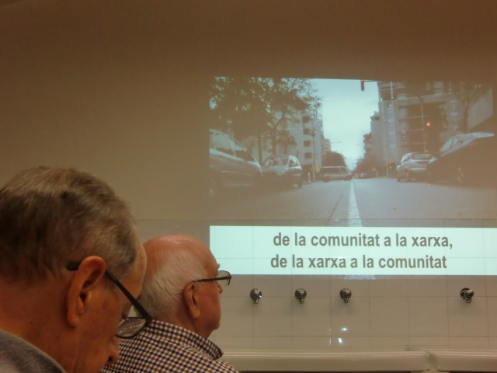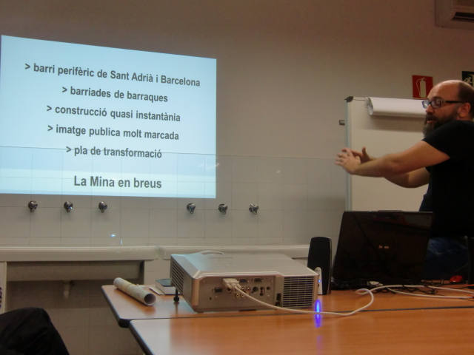
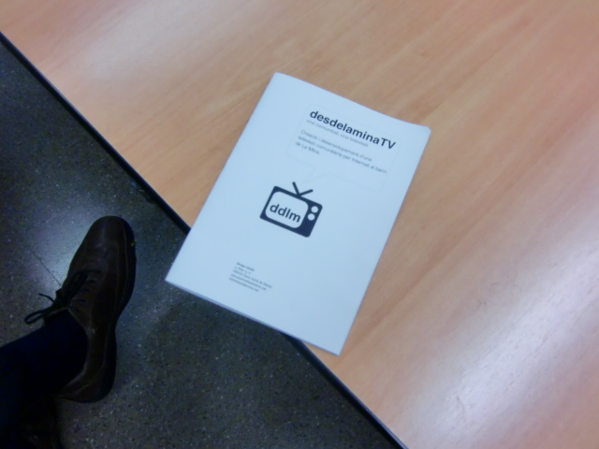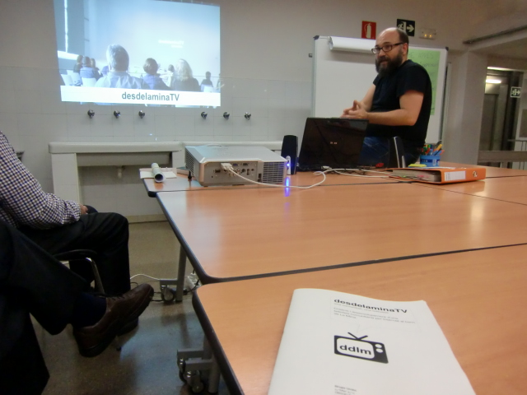

Session | 8
Date | 29/11/2016
Duration | 2h
Title | Starting the script
Objectives
Contents | - Writing a first draft of the script with the participation of Alberto Bougleux Popular Film School in Barcelona
Further information | http://www.eulerproject.eu/2016/10/26/som-la-marina-activitats-novembre/ http://www.eulerproject.eu/2016/12/12/som-la-marina-rutes-memoria-i-territori/

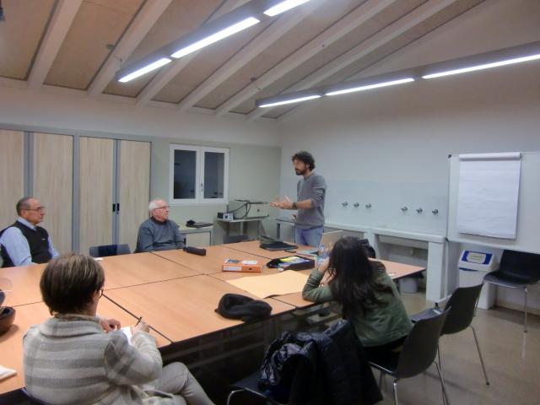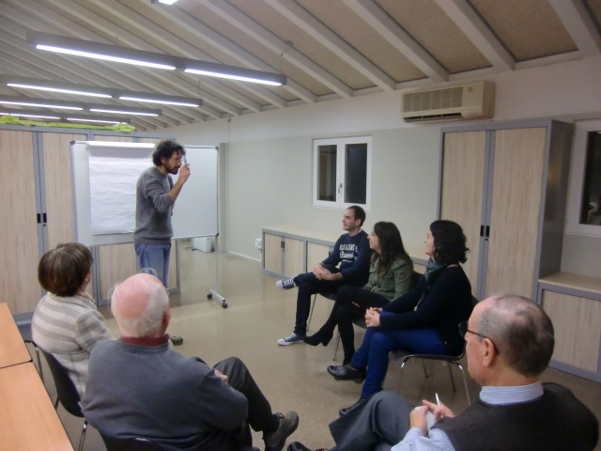
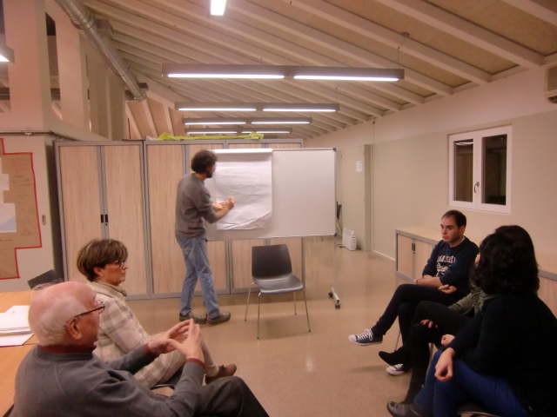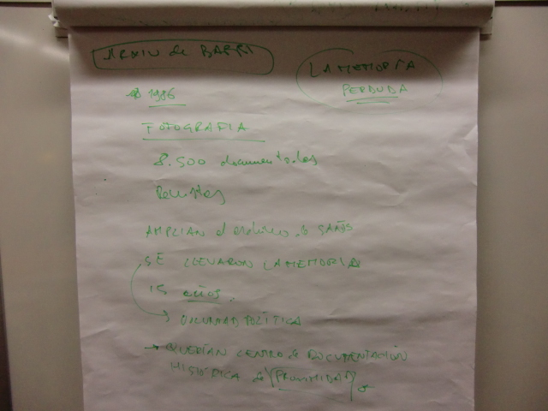

Session | 9
Date | 13/12/2016
Duration | 2h
Title | Planning
Objectives
Contents | - Planning work for the next quarter
Further information | http://www.eulerproject.eu/2016/12/12/som-la-marina-activitats-desembre/  http://www.eulerproject.eu/2017/01/05/som-la-marina-definicio-i-tancament-del-guio/

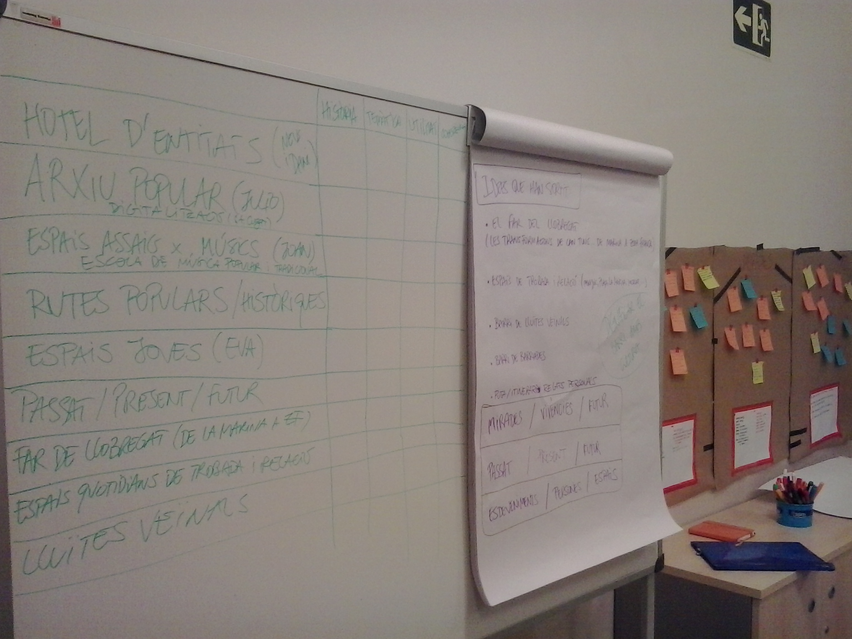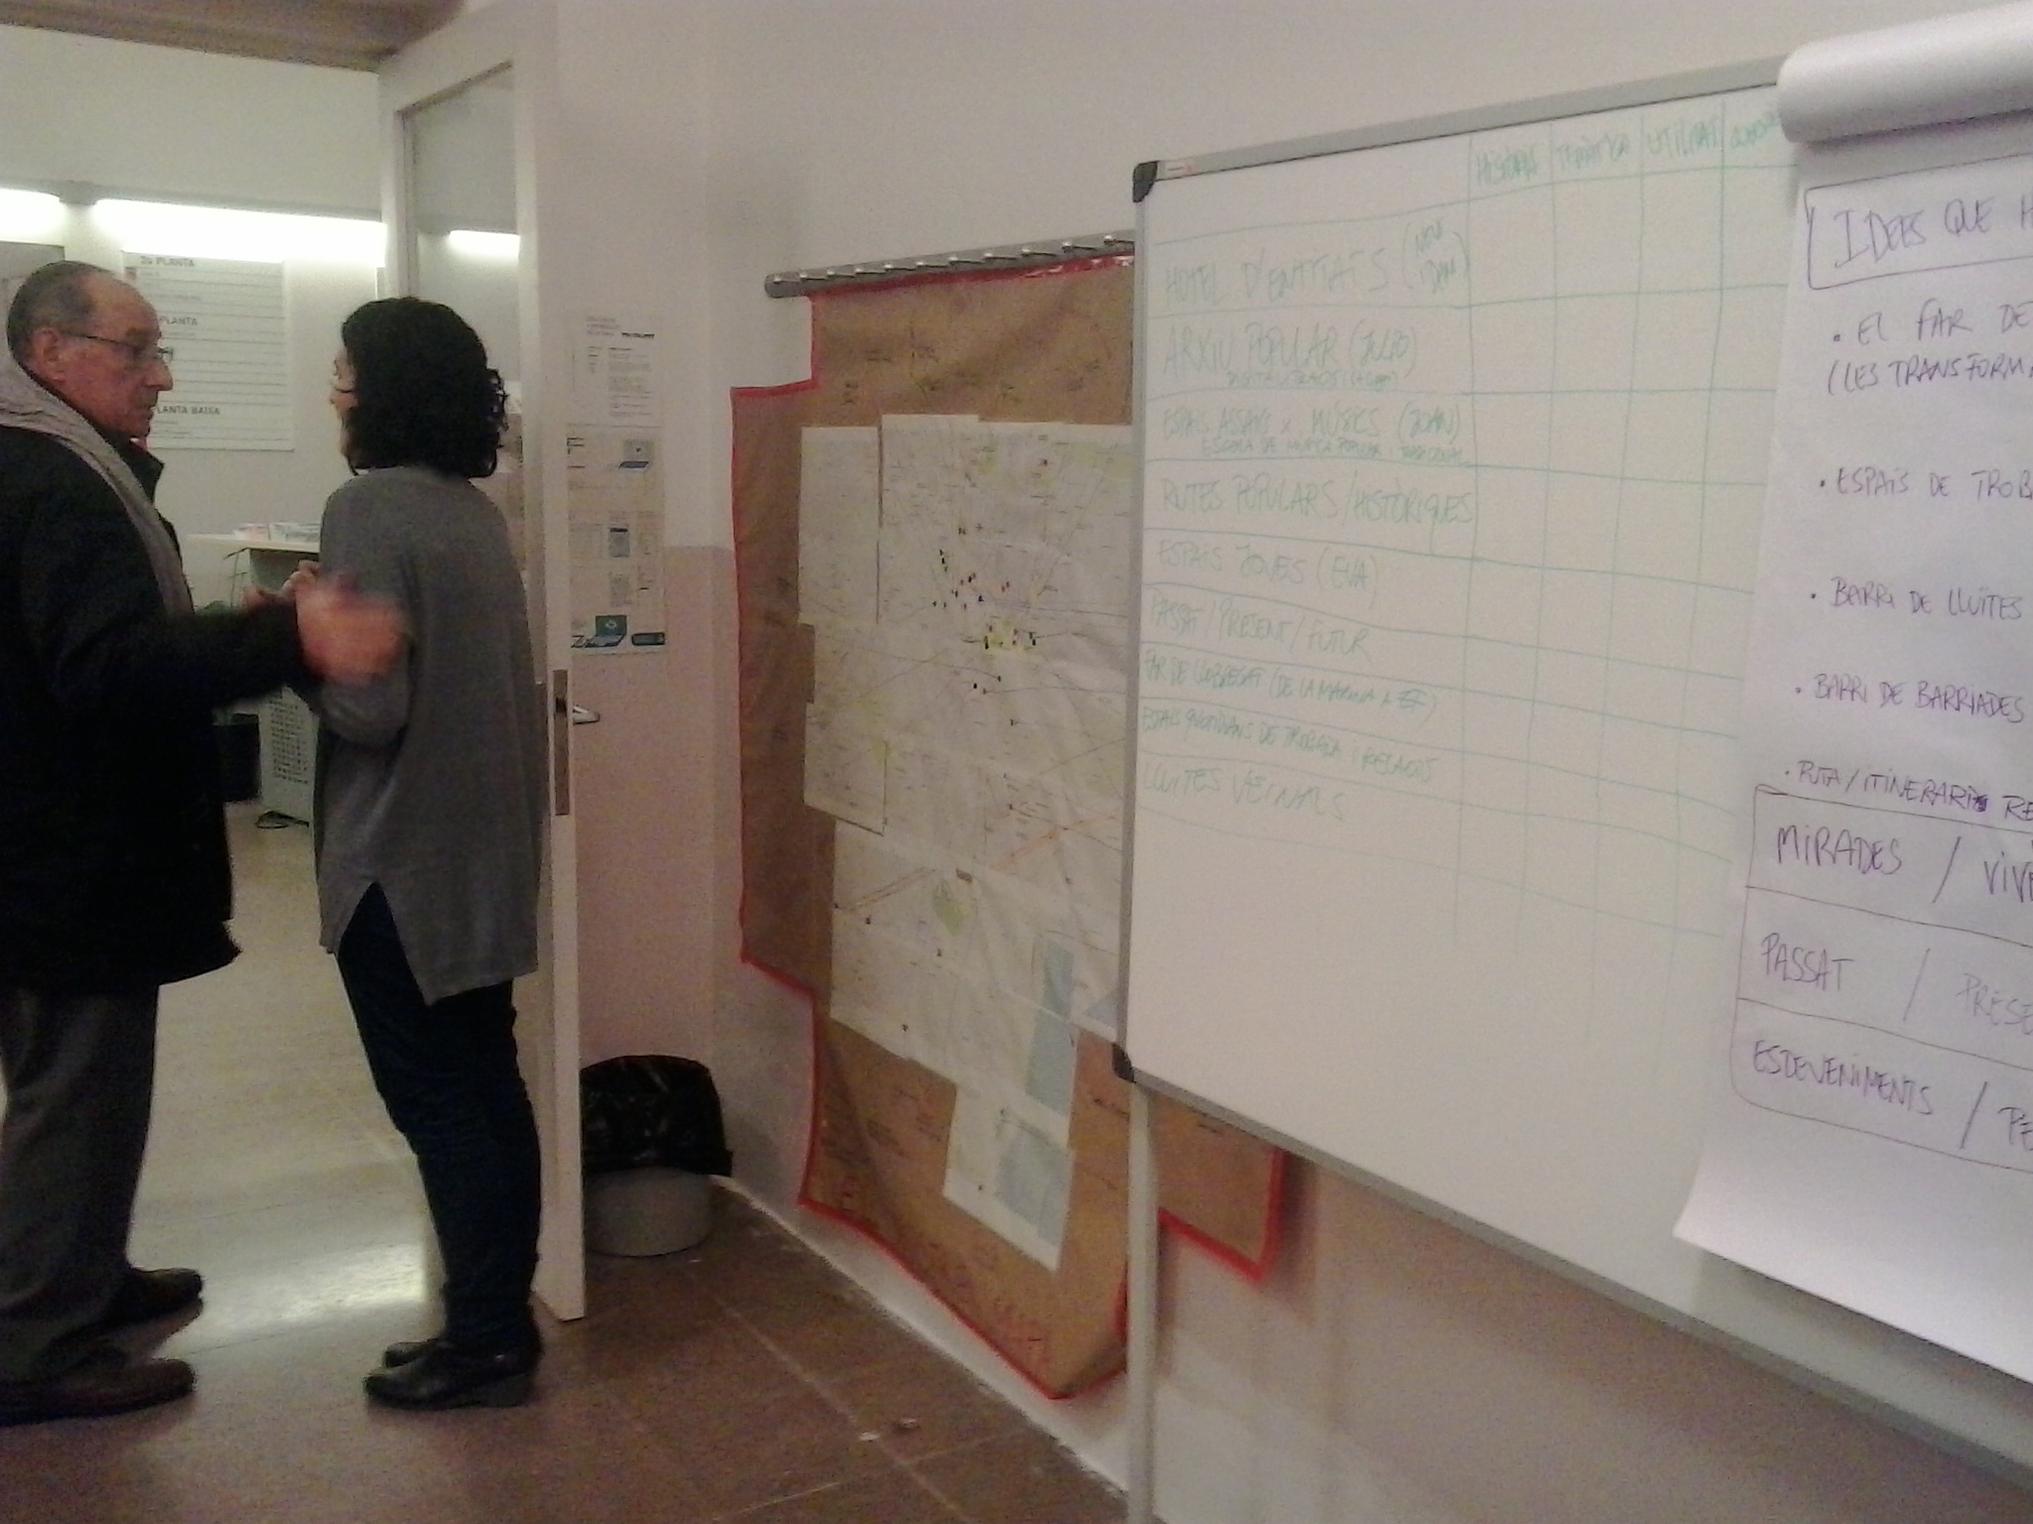
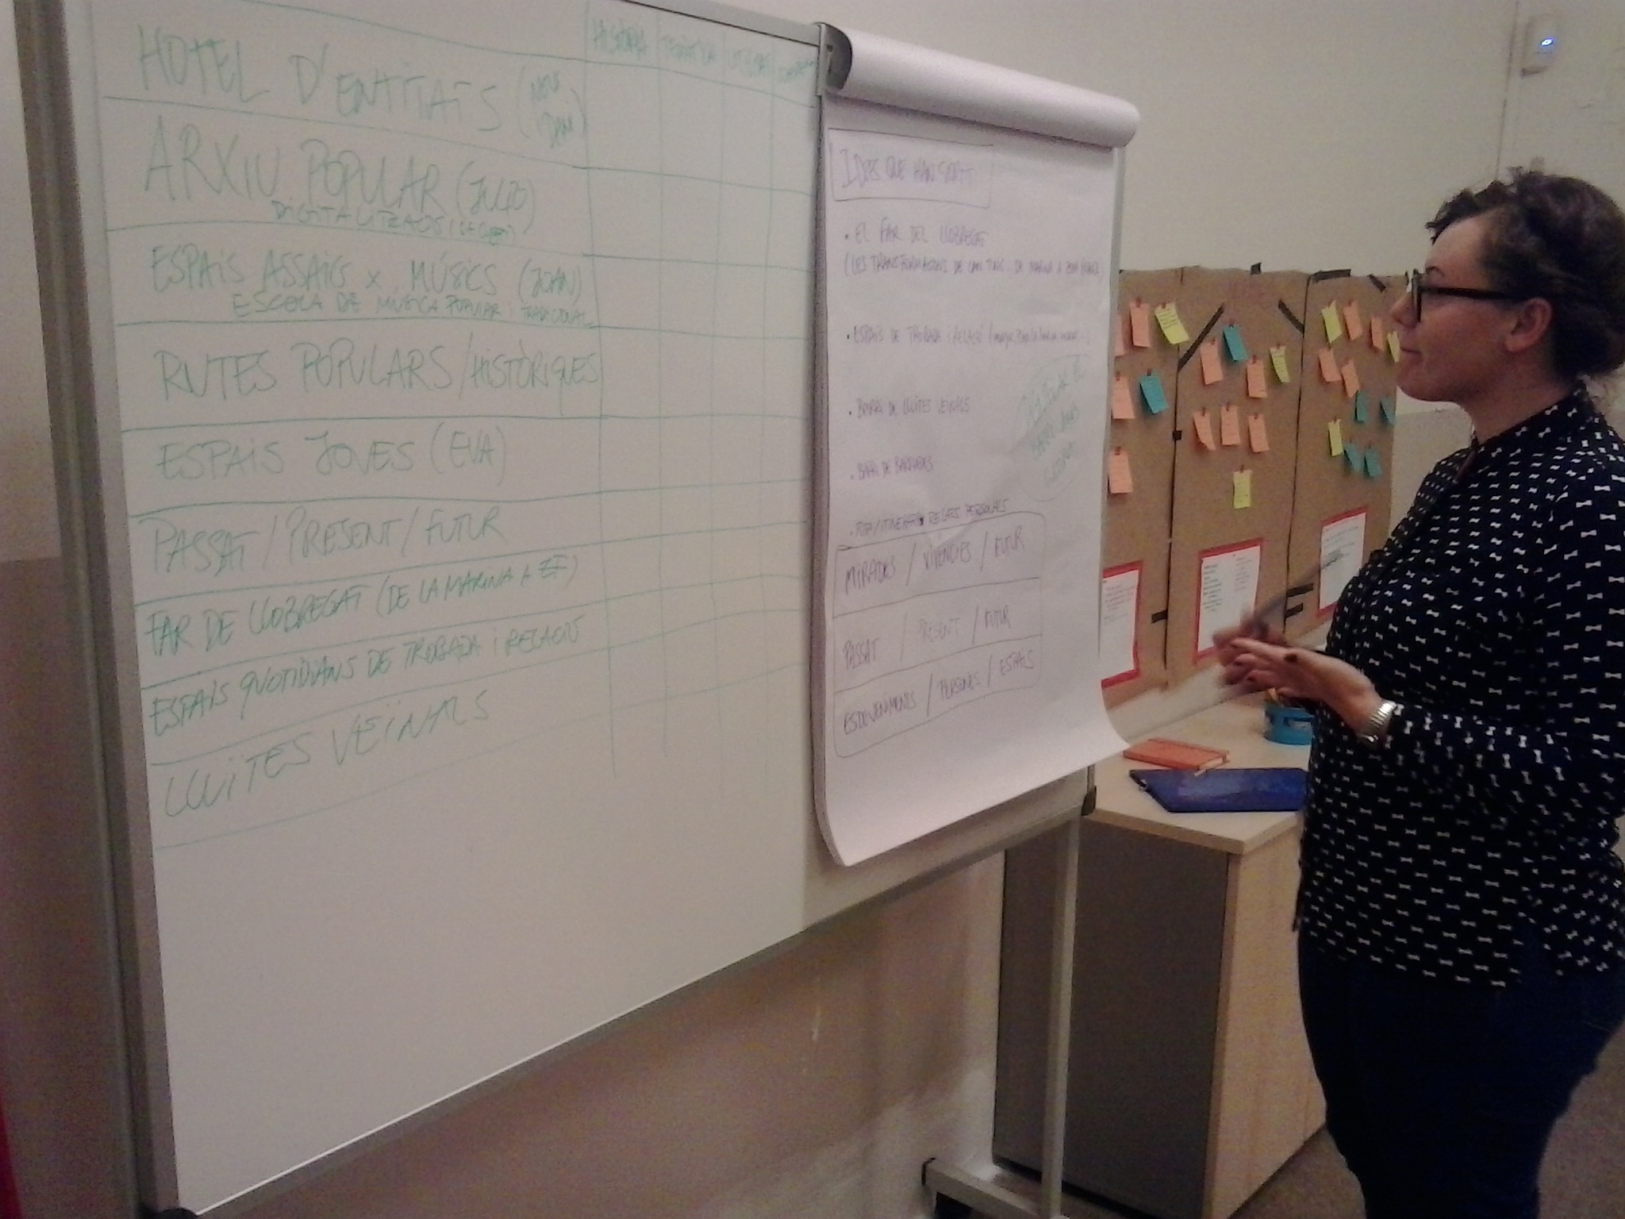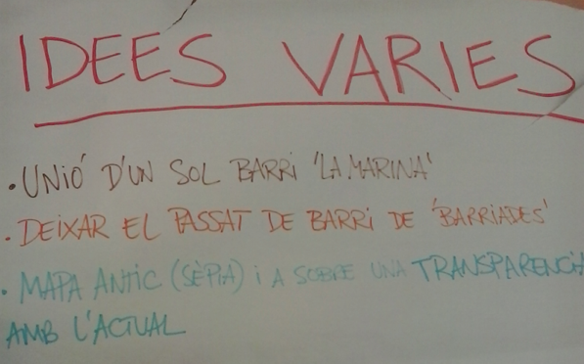

Session | 10
Date | 20/12/2016
Duration | 2h
Title | Evaluation and networking
Objectives
Contents | - Evaluation of the process until now.  - Closure of the first part of training  - Presentation of the project Barris & Films by the Catalan Federation of Cineclubs (Julio Lamaña)
Further information | http://www.eulerproject.eu/2016/12/12/som-la-marina-activitats-desembre/  http://www.eulerproject.eu/2017/01/05/som-la-marina-definicio-i-tancament-del-guio/

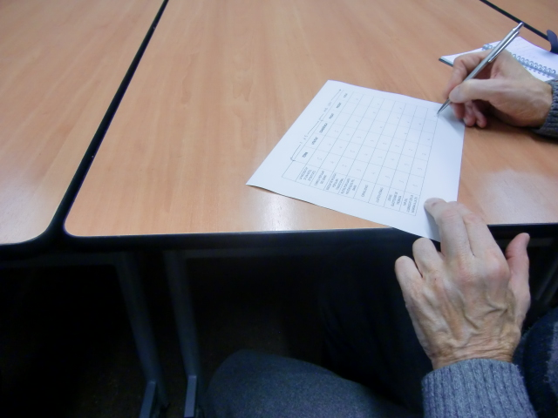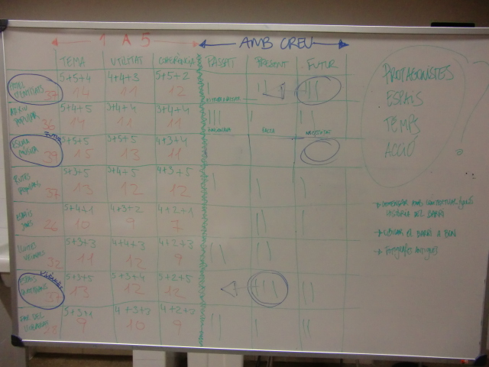
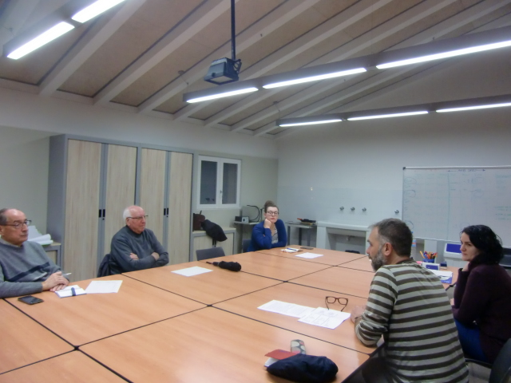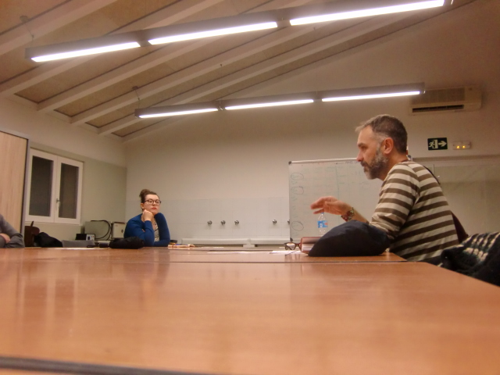

Session | 11
Date | 10/01/2017
Duration | 2h
Title | Script and planning
Objectives
Contents | - Point situation.  - Definition of objectives and working plan  - Closing Script  - Scheduling recordings, procedures and task distribution
Further information | http://www.eulerproject.eu/2017/01/05/som-la-marina-activitats-gener-2017/  http://www.eulerproject.eu/2017/02/05/som-la-marina-planificant-les-gravacions/

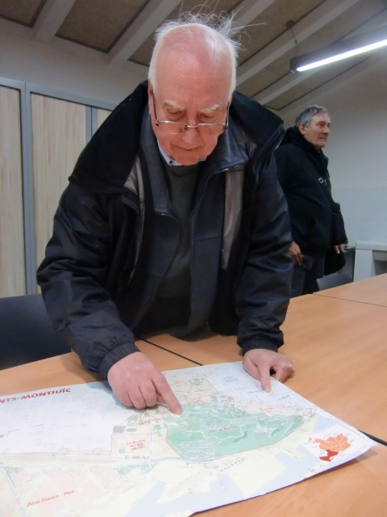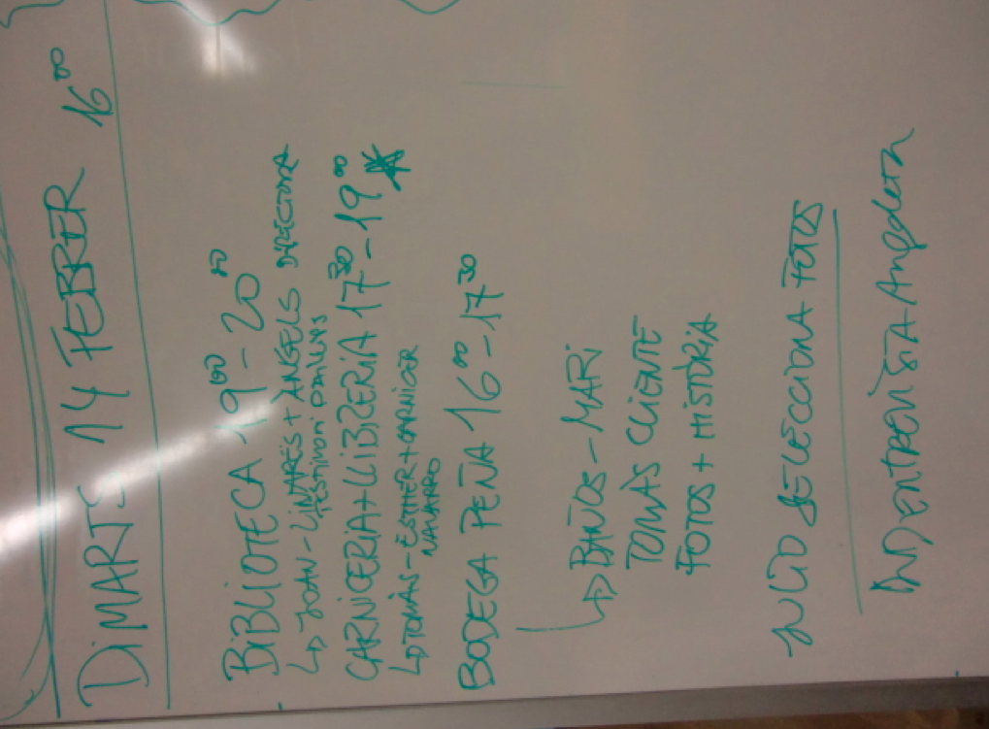
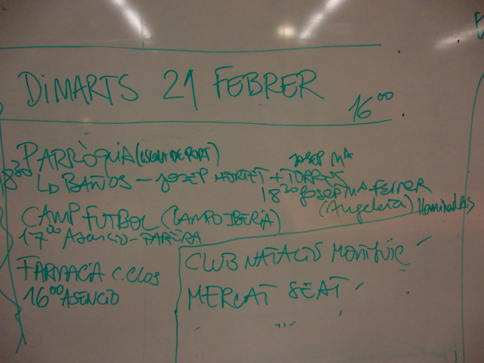

Session | 12
Date | 20/01/2017
Duration | 2h
Title | Technical aspects and video editing
Objectives
Contents | - Guidelines and technical aspects of video editing (by Patri Gomez, camera and editor in several audiovisual projects)
Further information | http://www.eulerproject.eu/2017/01/05/som-la-marina-activitats-gener-2017/  http://www.eulerproject.eu/2017/02/05/som-la-marina-planificant-les-gravacions/

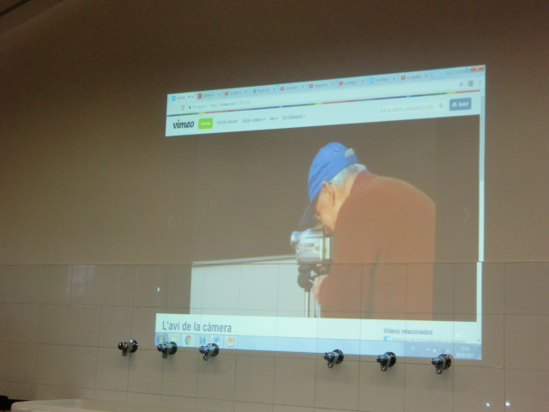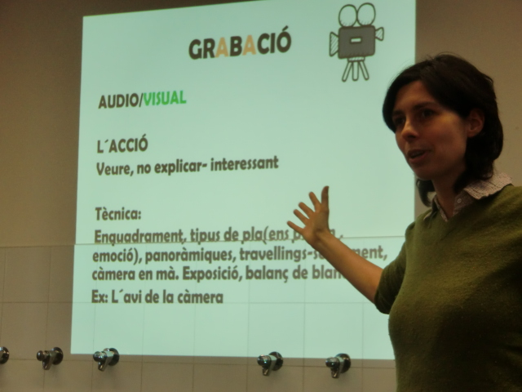
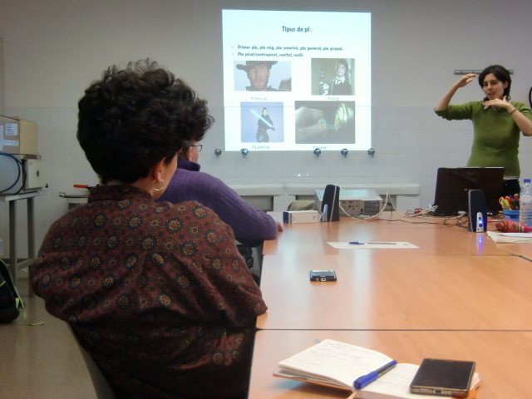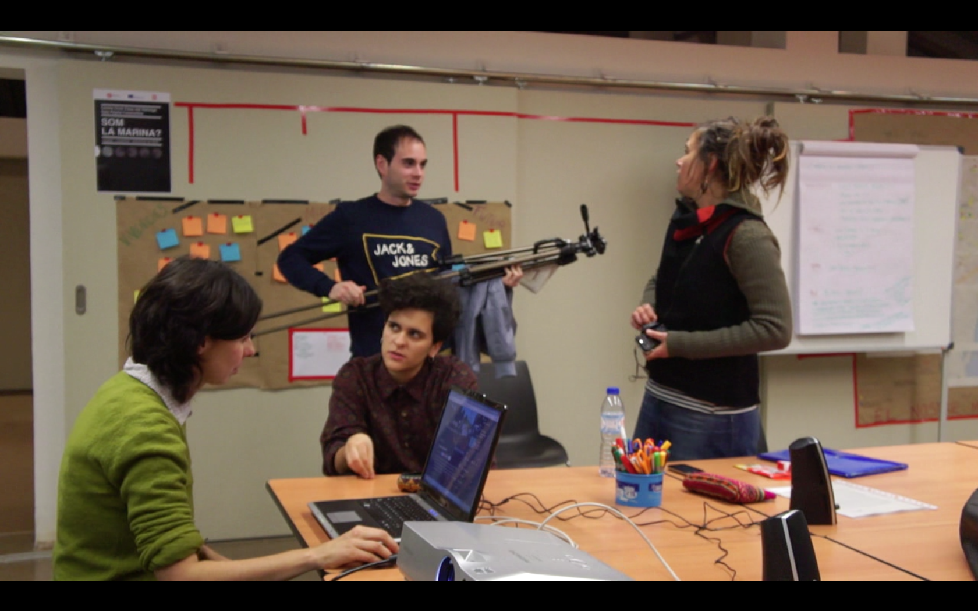

Session | 13
Date | 24/01/2017
Duration | 2h
Title | Practice
Objectives
Contents | - Practice shooting and recording (with the participation of Alberto Bougleux)
Further information | http://www.eulerproject.eu/2017/01/05/som-la-marina-activitats-gener-2017/  http://www.eulerproject.eu/2017/02/05/som-la-marina-planificant-les-gravacions/

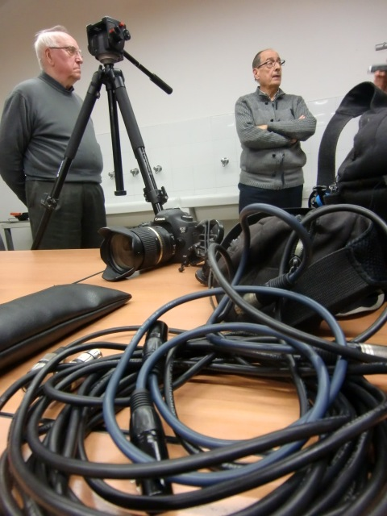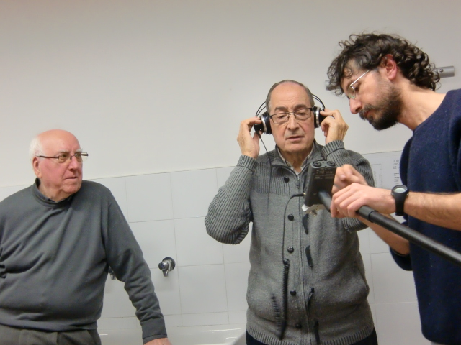
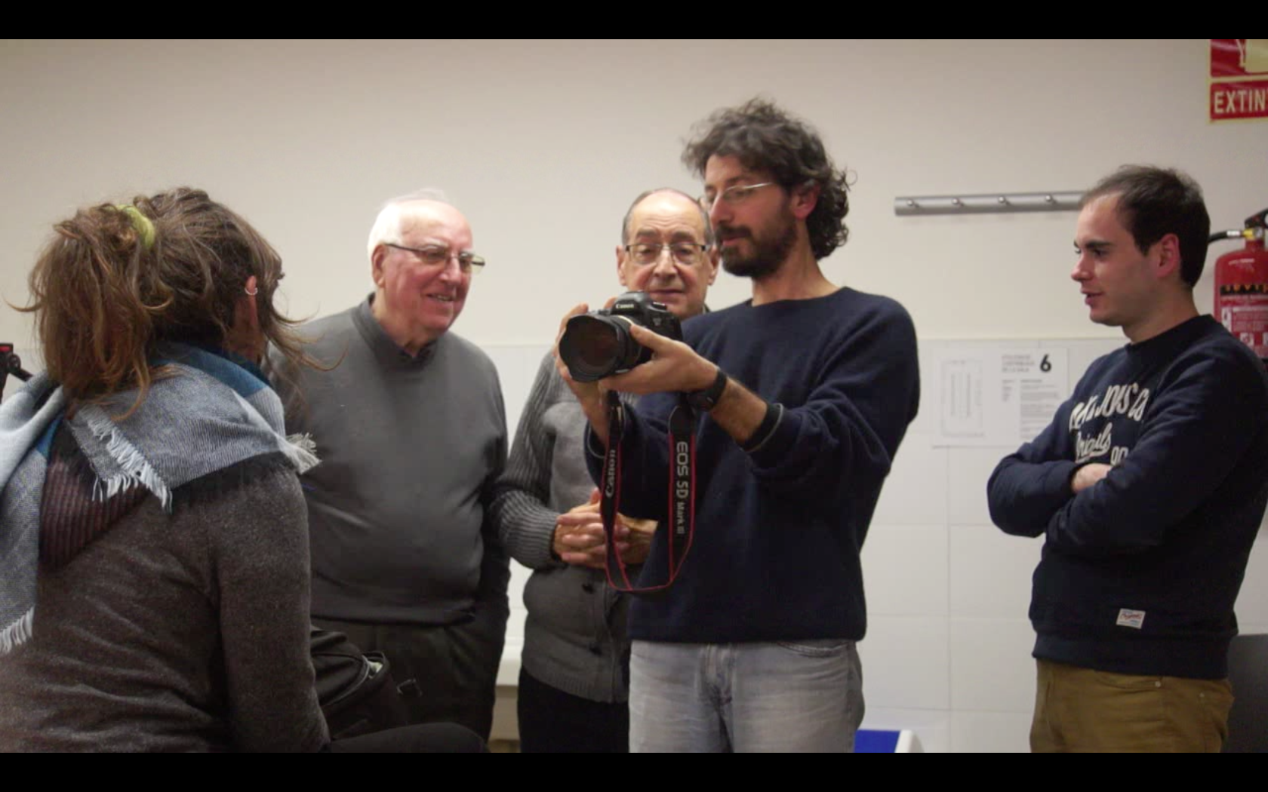

Session | 14
Date | 31/01/2017
Duration | 2h
Title | How to do an interview.
Objectives
Contents | - Planning for the contents of recordings  - Manual of good practice when we do interviews, by Ivana Ujcic journalist
Further information | http://www.eulerproject.eu/2017/01/05/som-la-marina-activitats-gener-2017/  http://www.eulerproject.eu/2017/02/05/som-la-marina-planificant-les-gravacions/

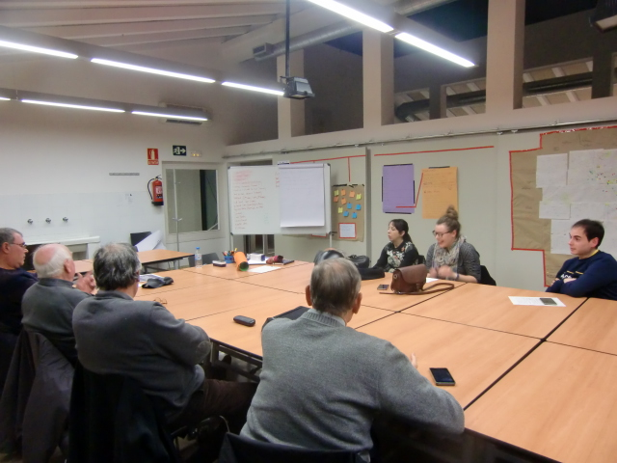
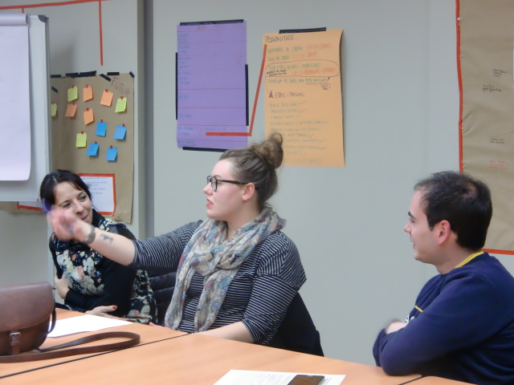

Session | 15
Date | 07/02/2017
Duration | 2h
Title | Ready to shoot?
Objectives
Contents | - Final decisions about filming and shooting,  - Distribution of tasks  - Preparation of the interviews
Further information | http://www.eulerproject.eu/2017/02/05/som-la-marina-activitats-febrer-2017/ http://www.eulerproject.eu/2017/03/05/som-la-marina-llums-camera-accio/

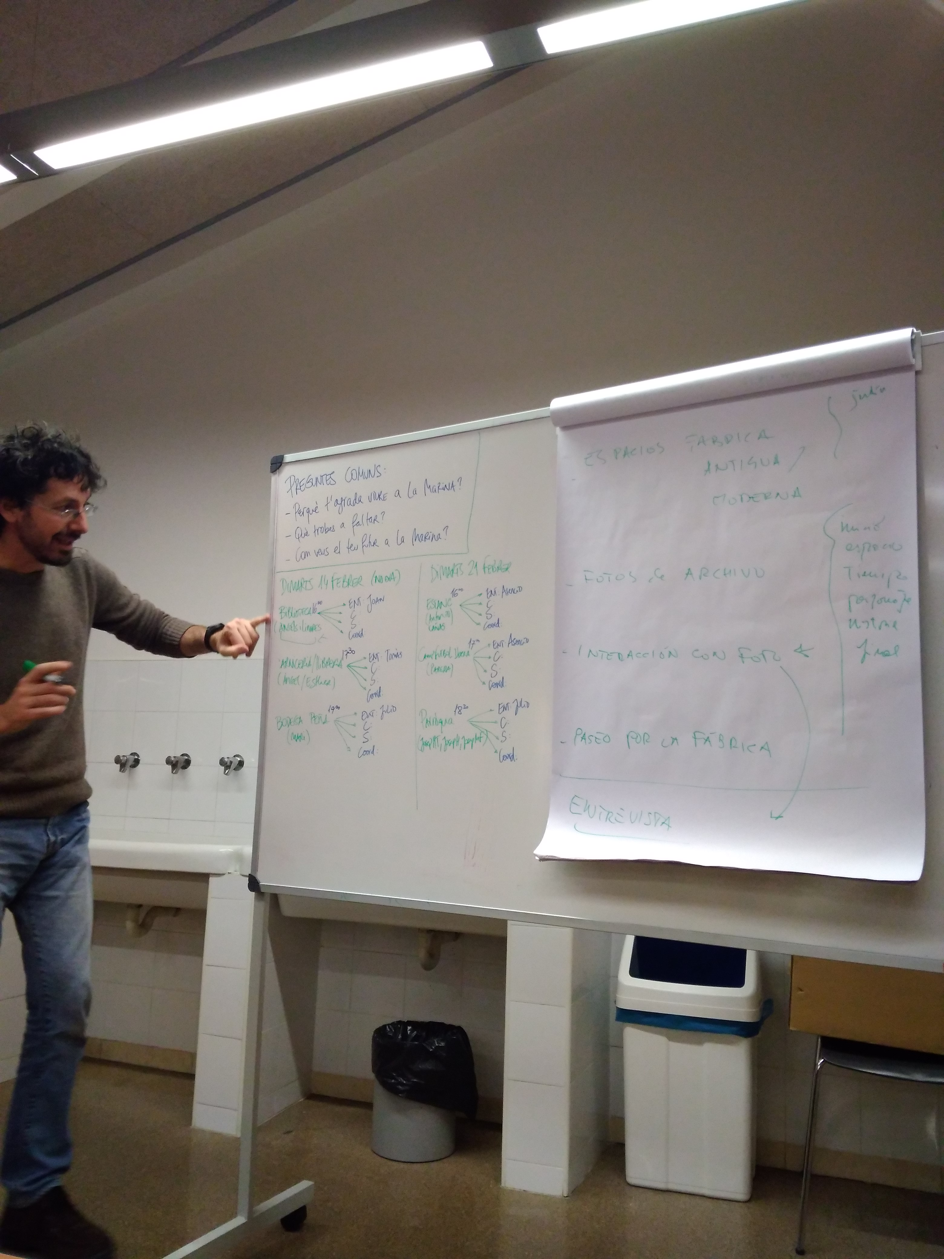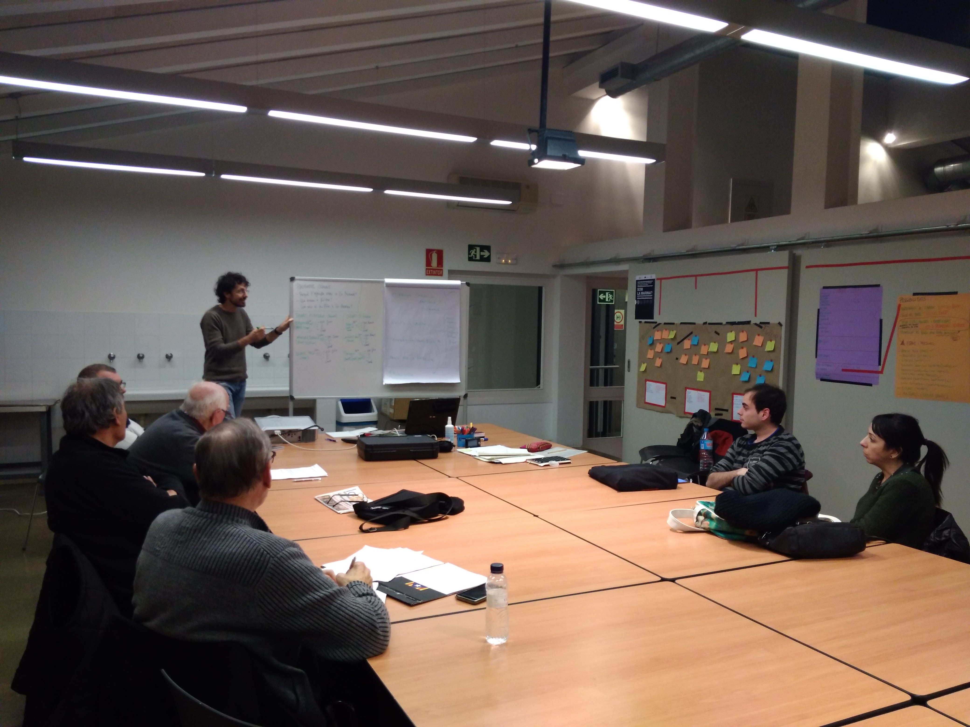

Session | 16
Date | 14/02/2017
Duration | 4h
Title | Filming
Objectives
Contents | Shooting at Francesc Candel Public Library and at Bodega Peña
Further information | http://www.eulerproject.eu/2017/02/05/som-la-marina-activitats-febrer-2017/ http://www.eulerproject.eu/2017/03/05/som-la-marina-llums-camera-accio/

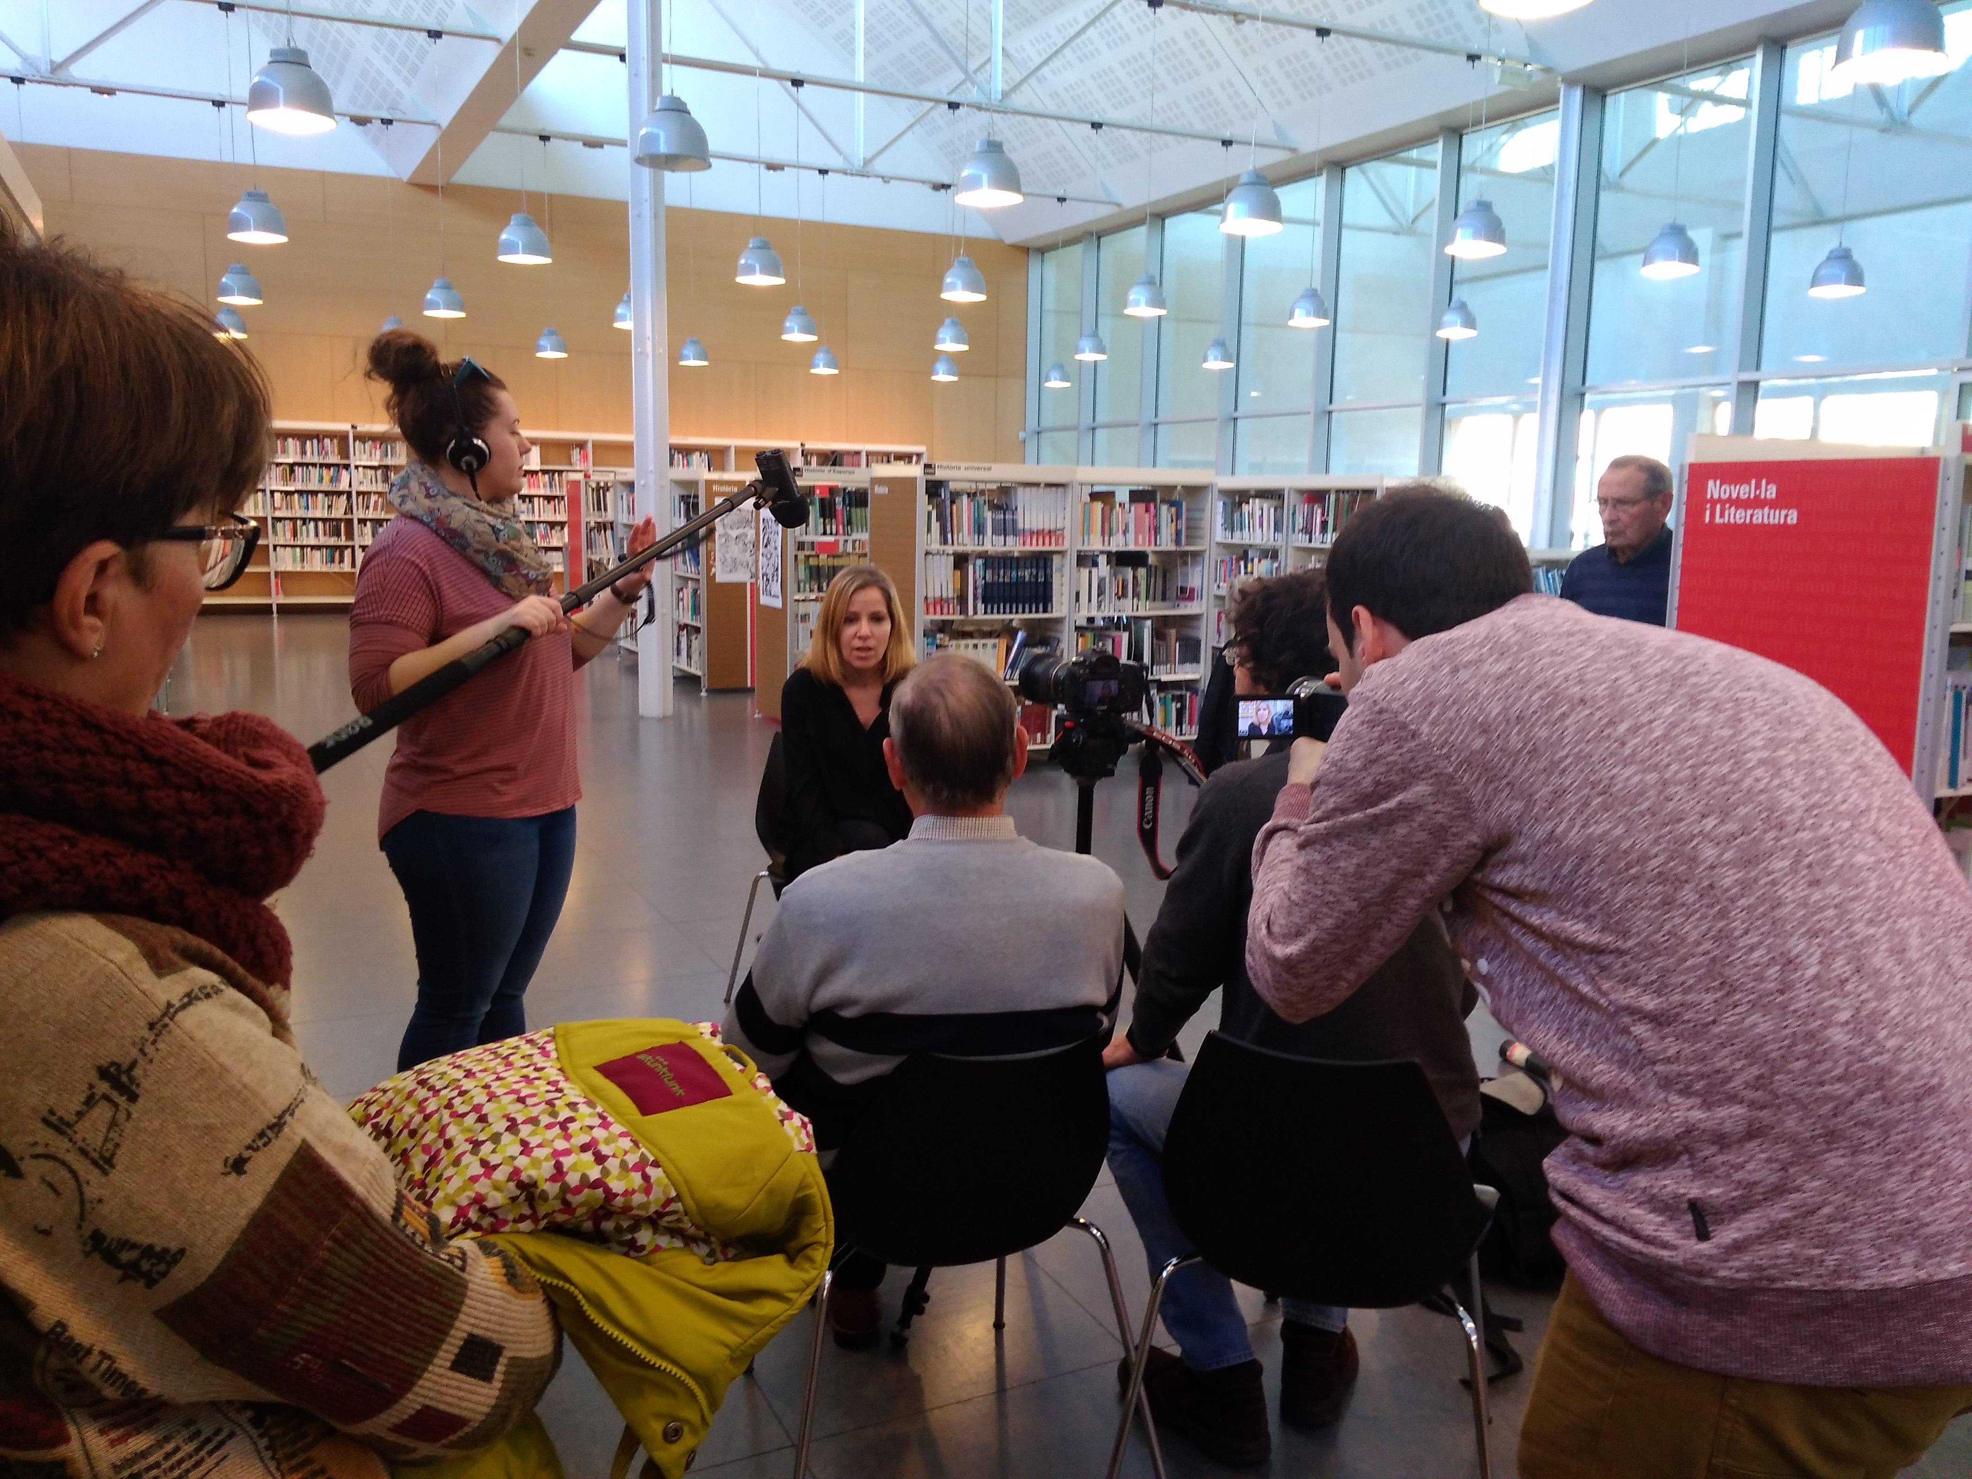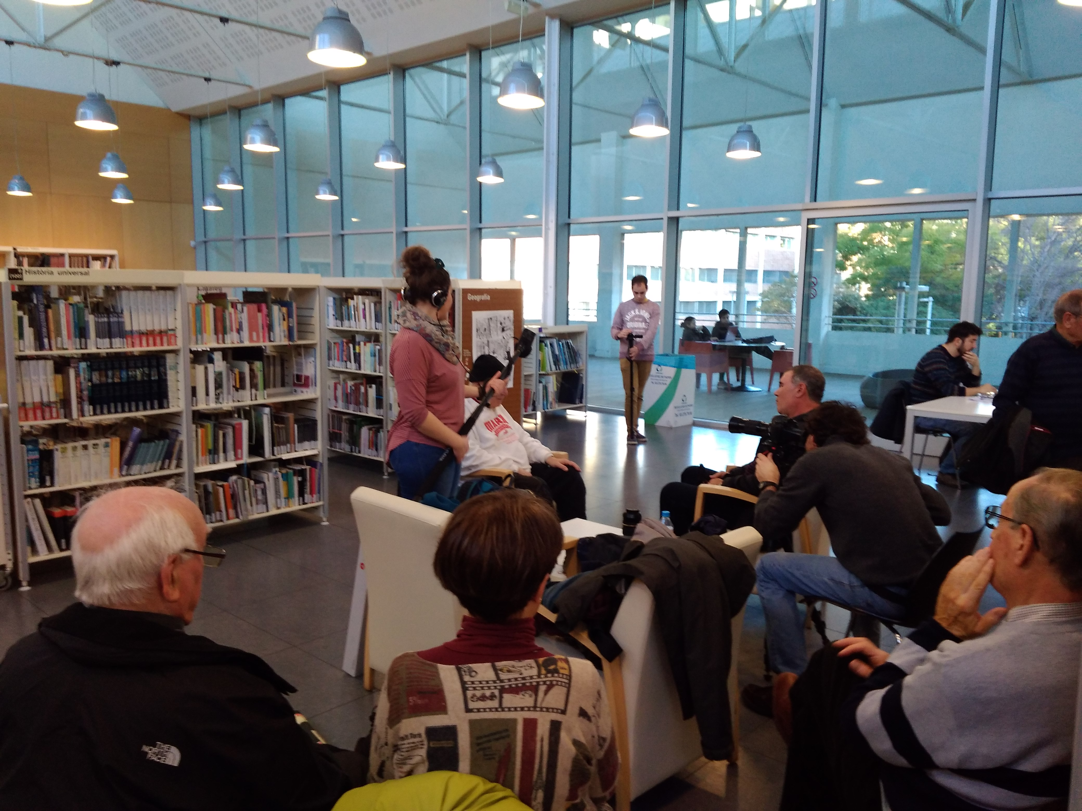
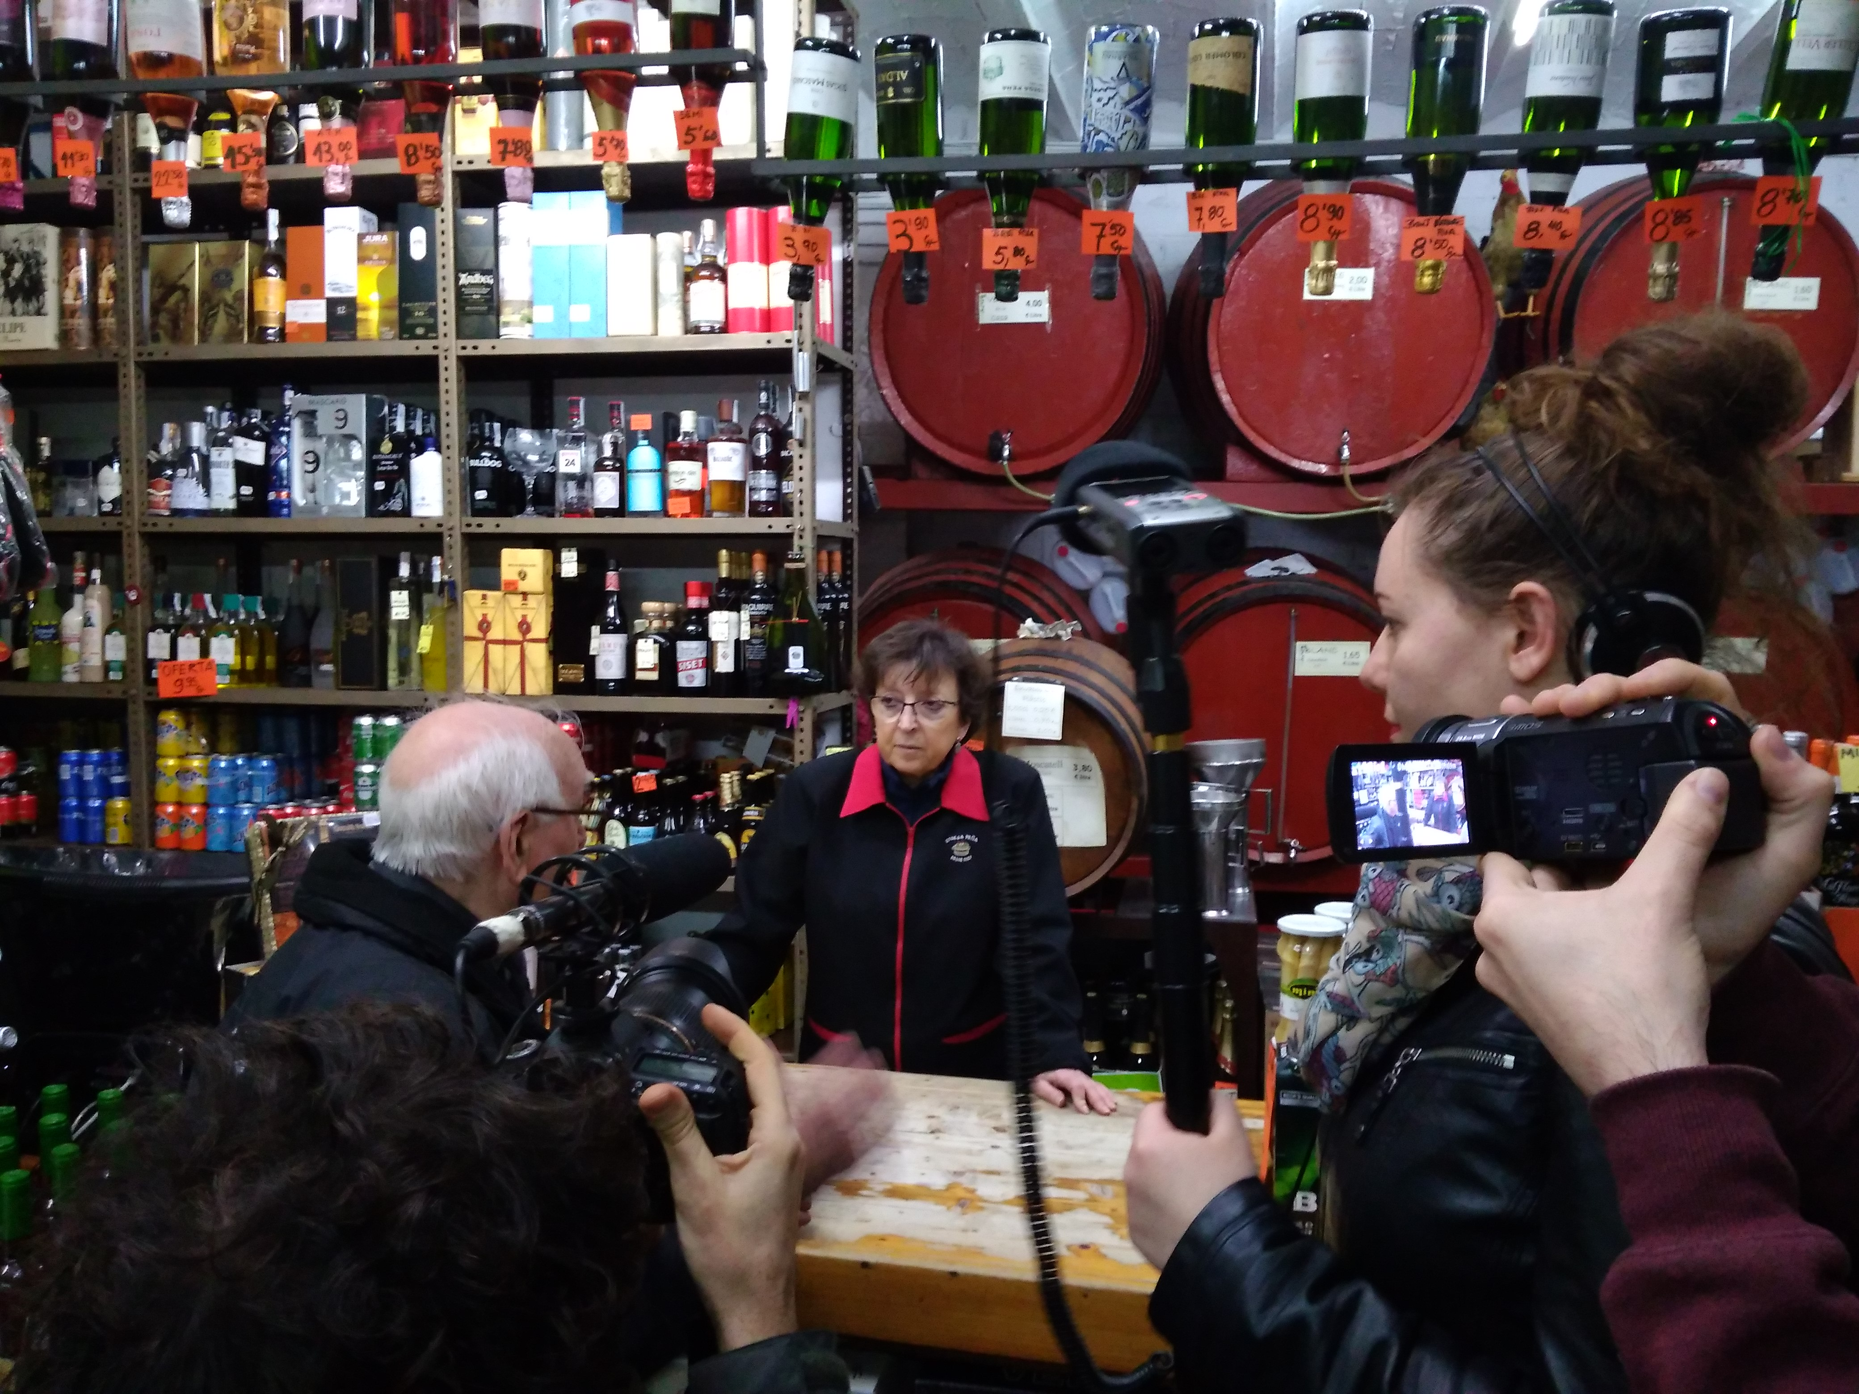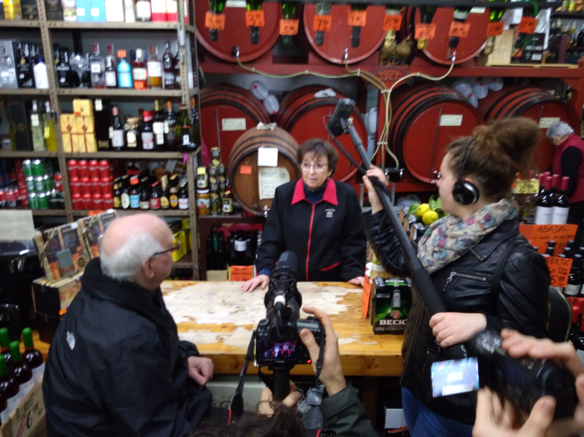

Session | 17
Date | 21/02/2017
Duration | 4h
Title | Filming
Objectives
Contents | Shooting at the Tobacco store, Iberia's Soccer Camp and at the Parish
Further information | http://www.eulerproject.eu/2017/02/05/som-la-marina-activitats-febrer-2017/ http://www.eulerproject.eu/2017/03/05/som-la-marina-llums-camera-accio/

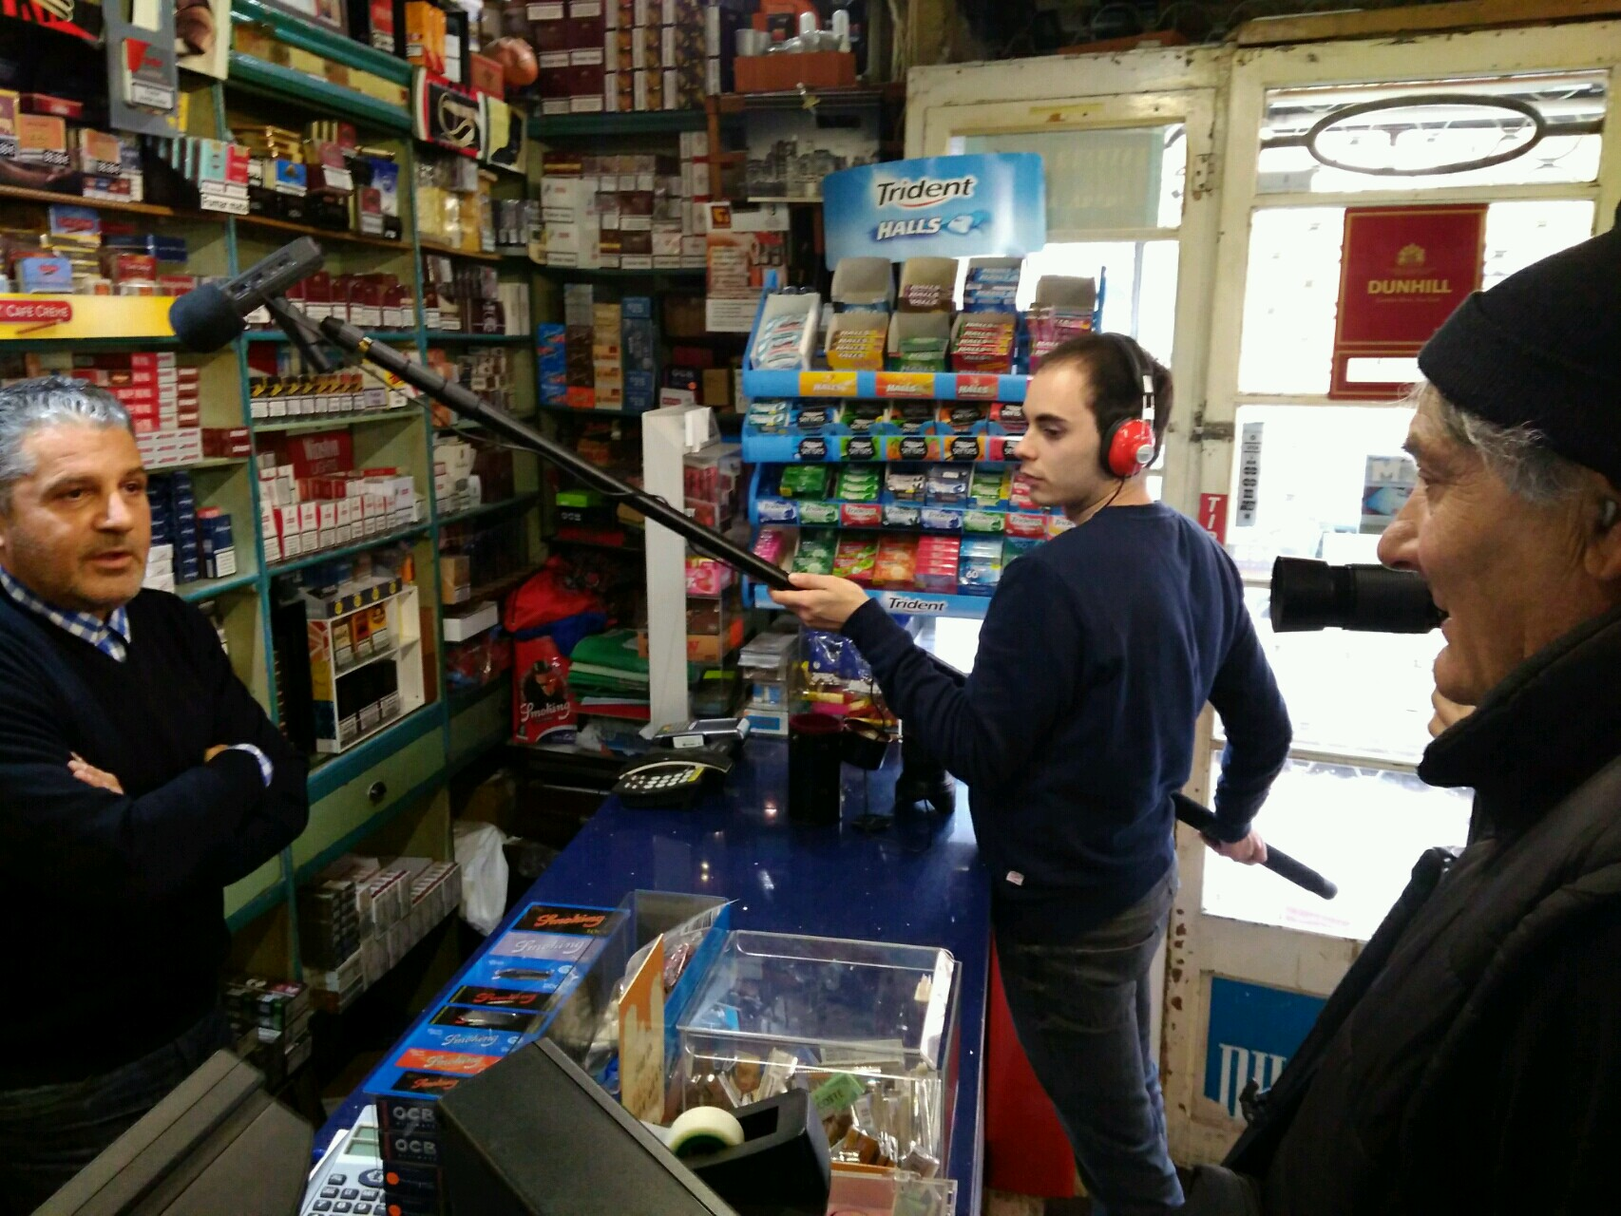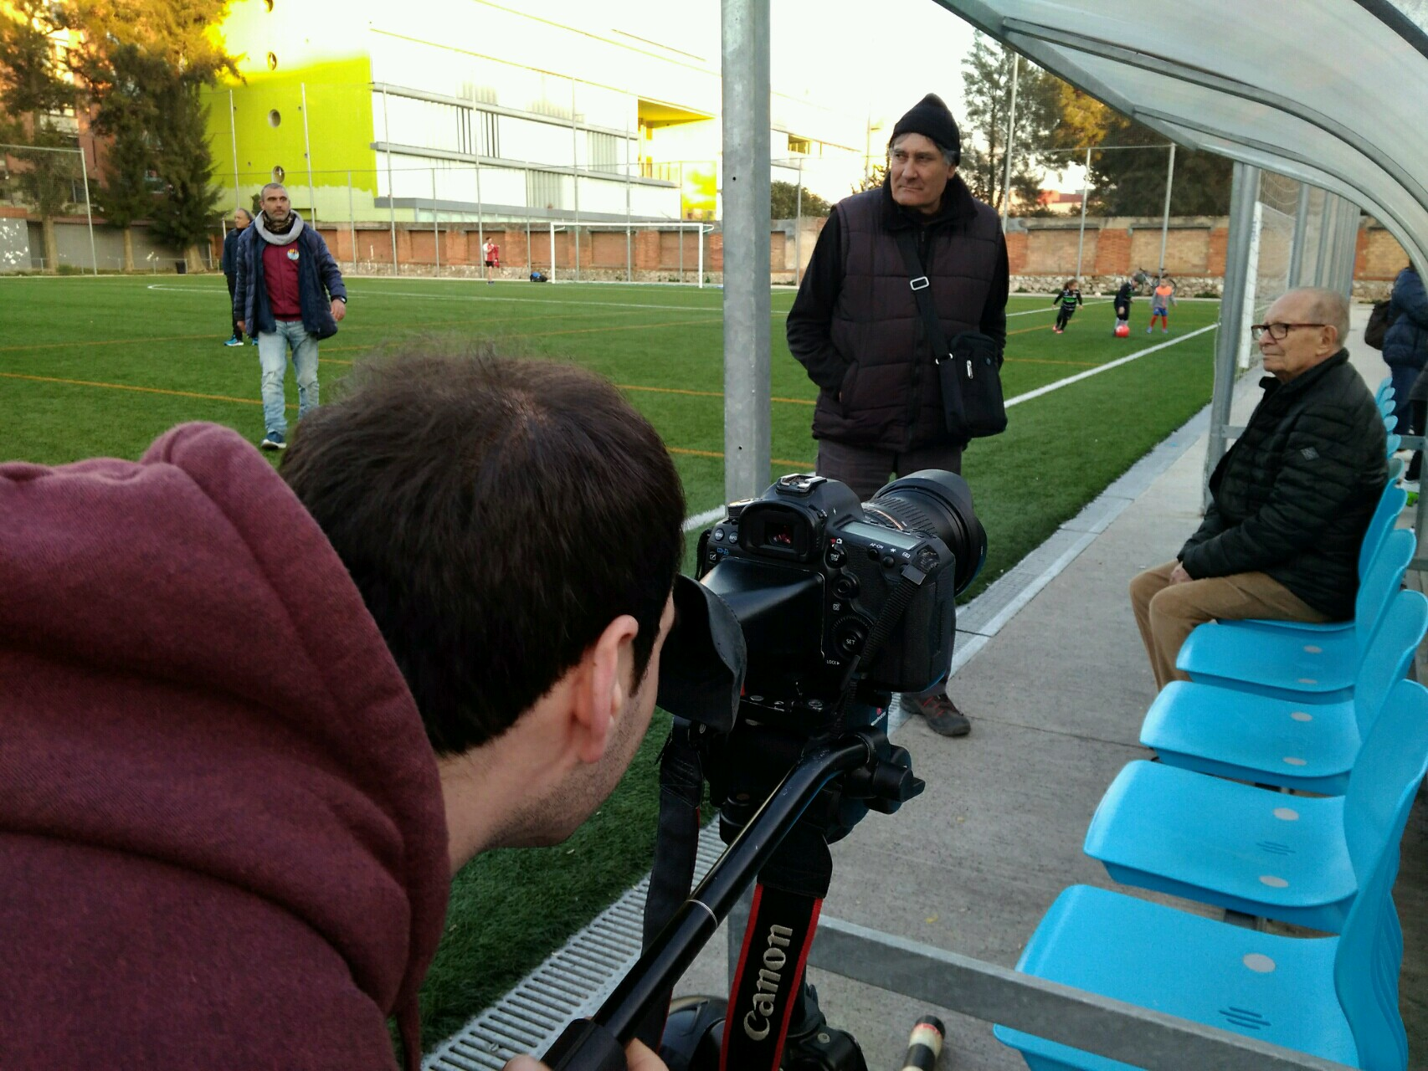
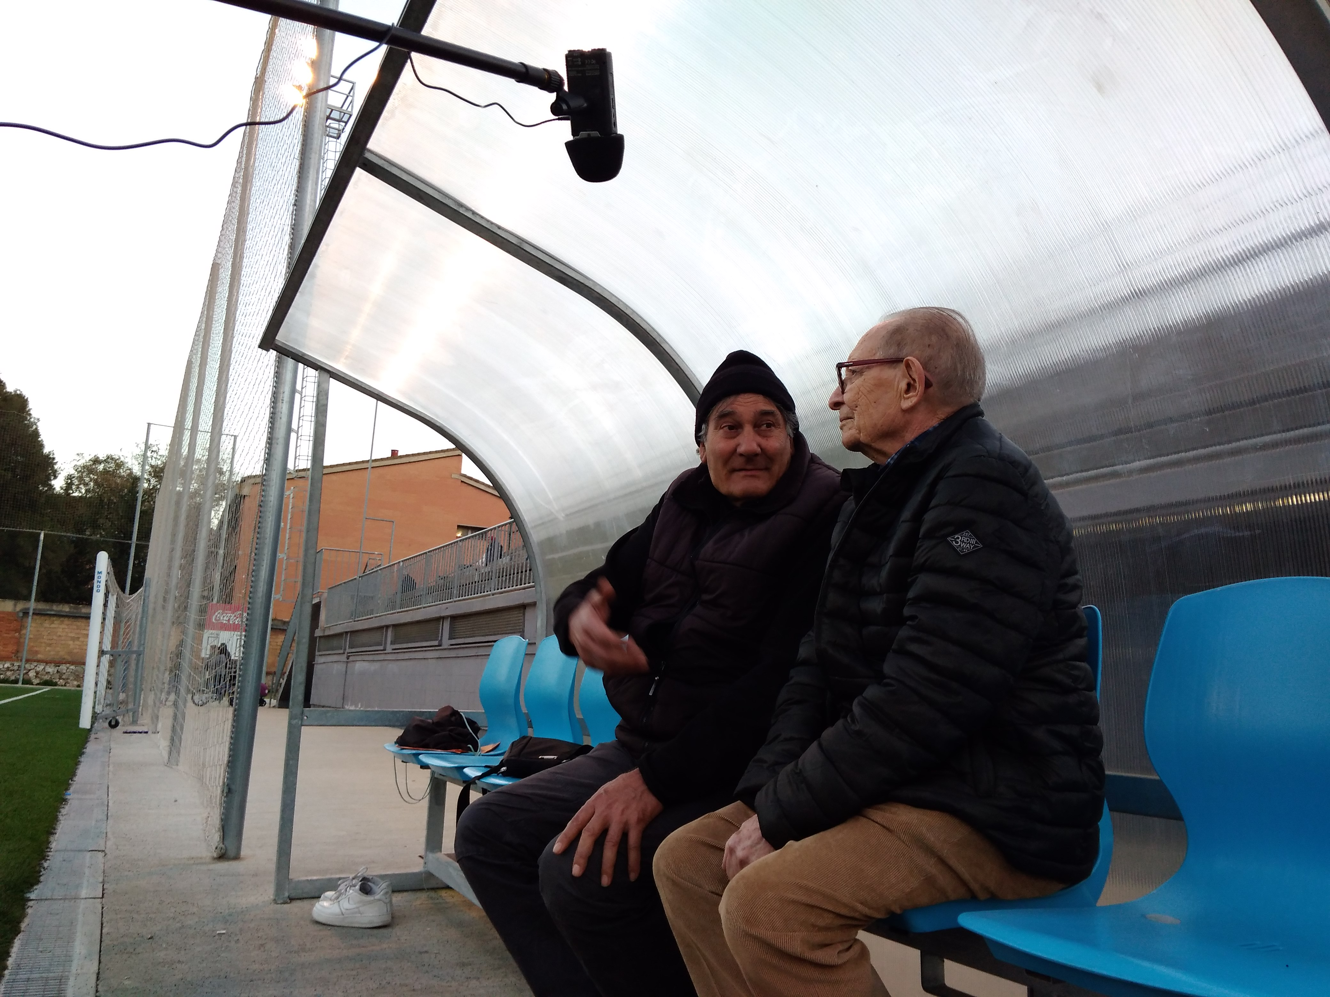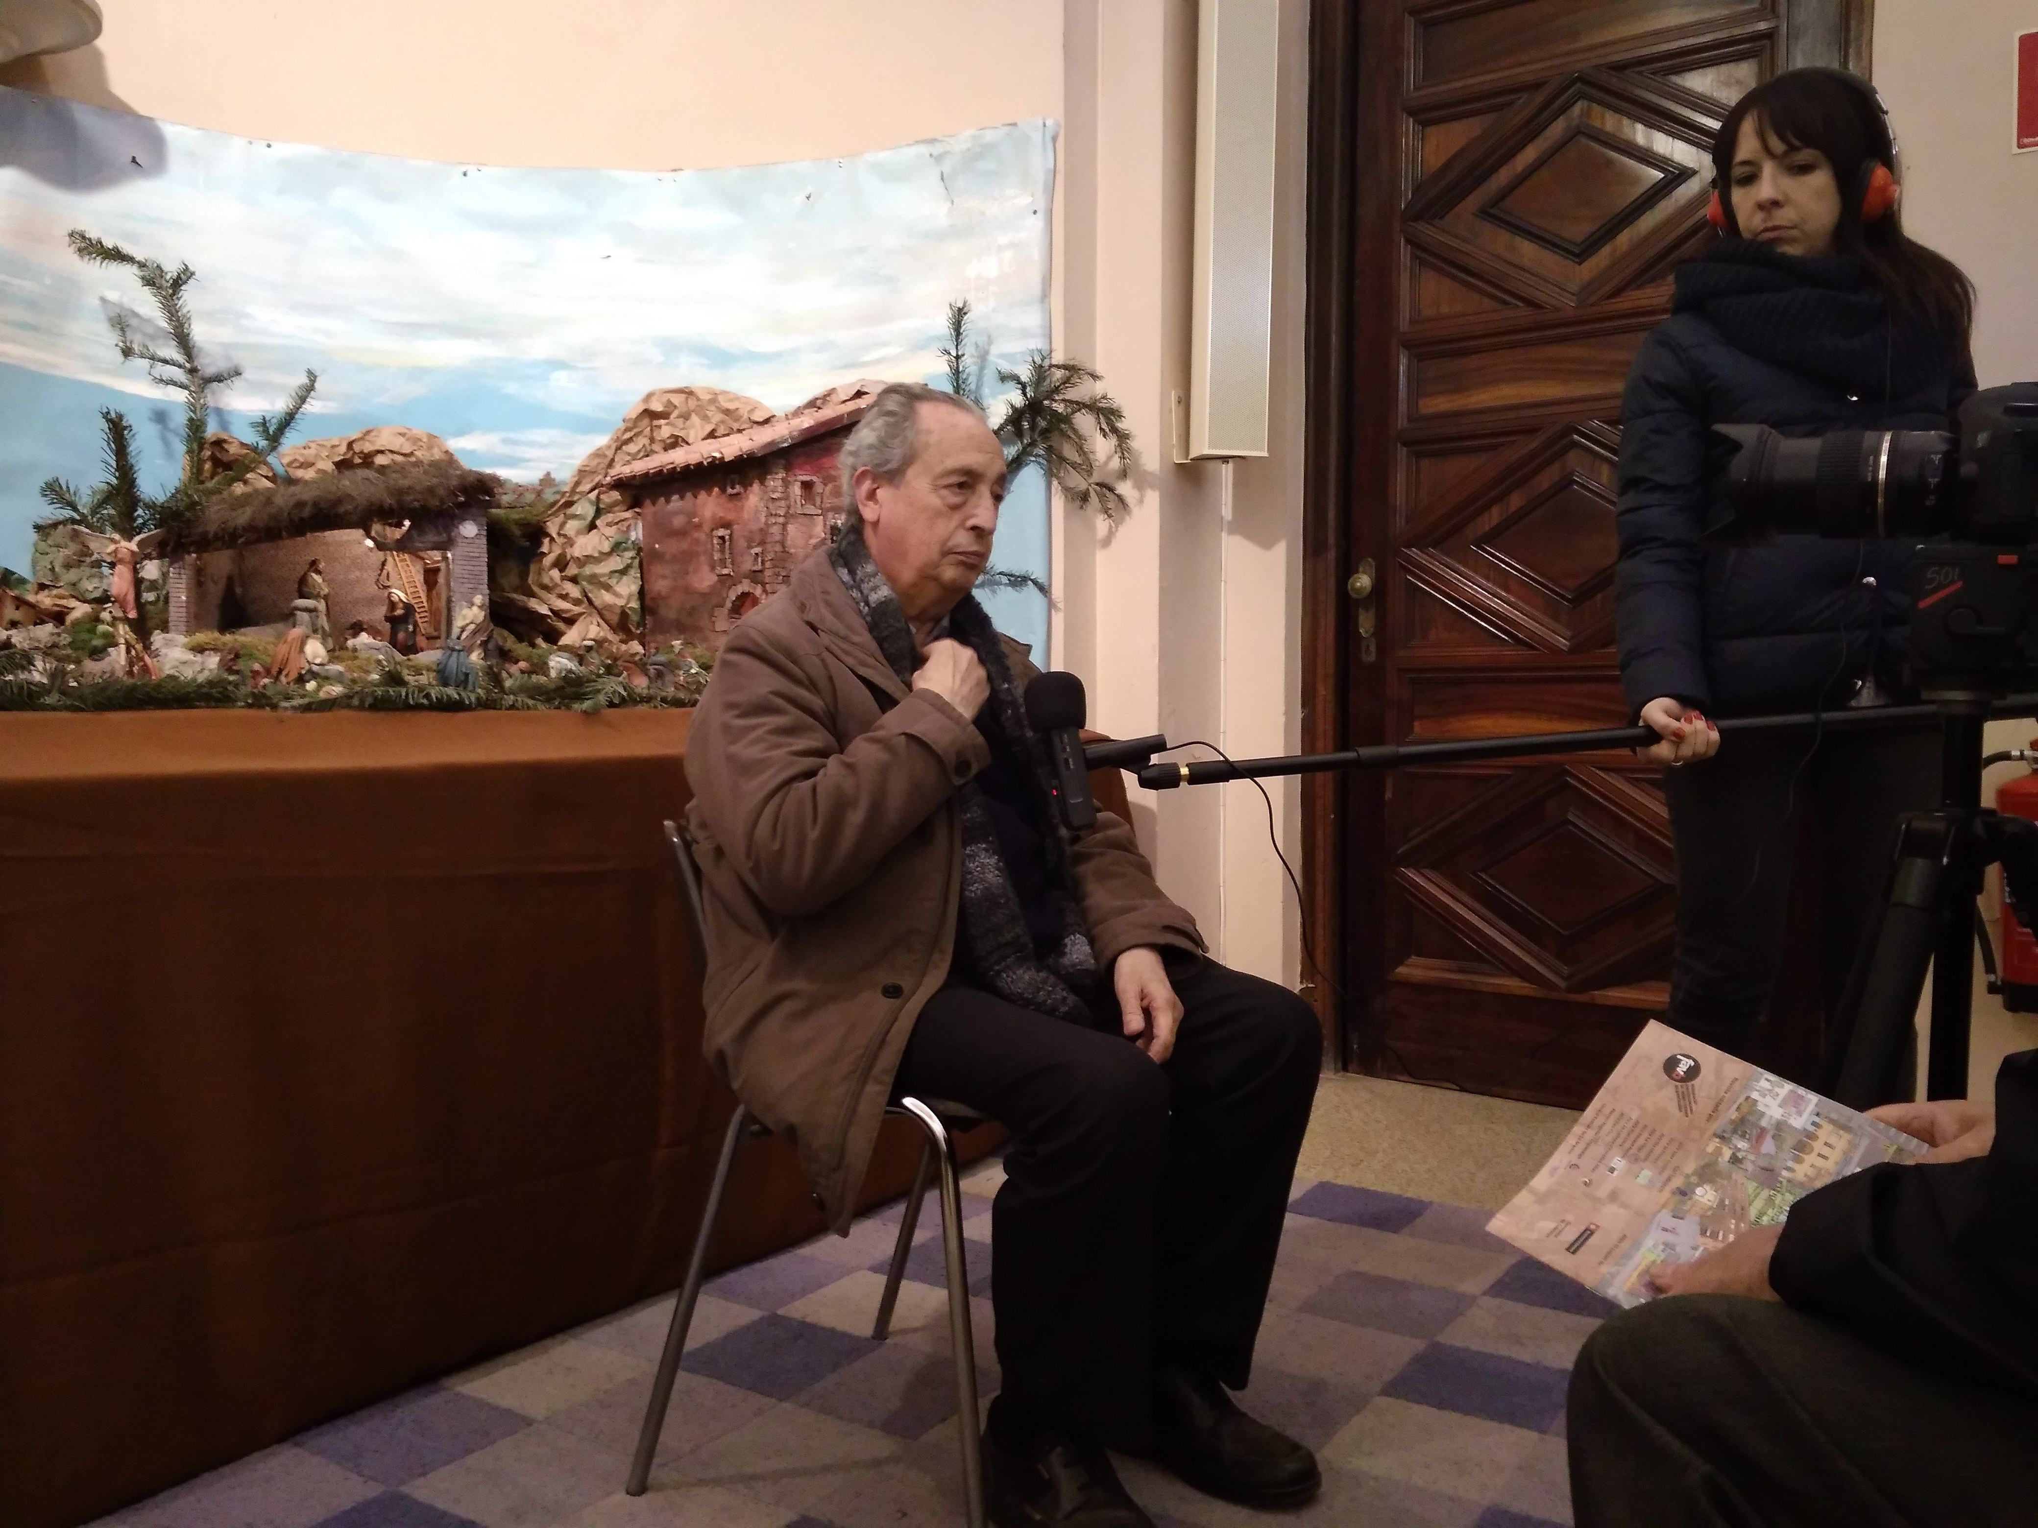

Session | 18
Date | 28/02/2017
Duration | 4h
Title | Filming
Objectives
Contents | - Recording images of La Marina neighborhood  - Recording the interview with Josep Maria Torres
Further information | http://www.eulerproject.eu/2017/02/05/som-la-marina-activitats-febrer-2017/ http://www.eulerproject.eu/2017/03/05/som-la-marina-llums-camera-accio/

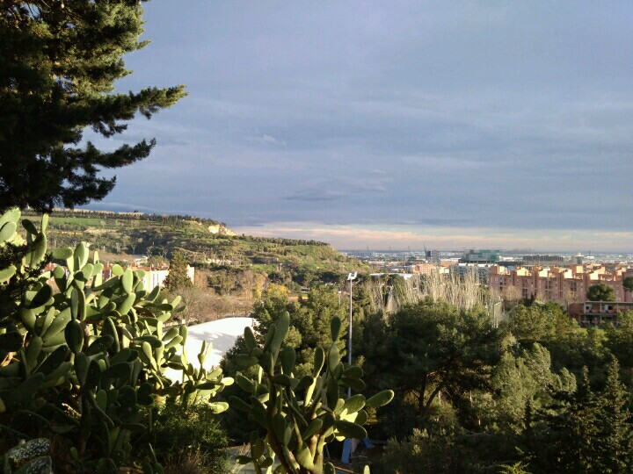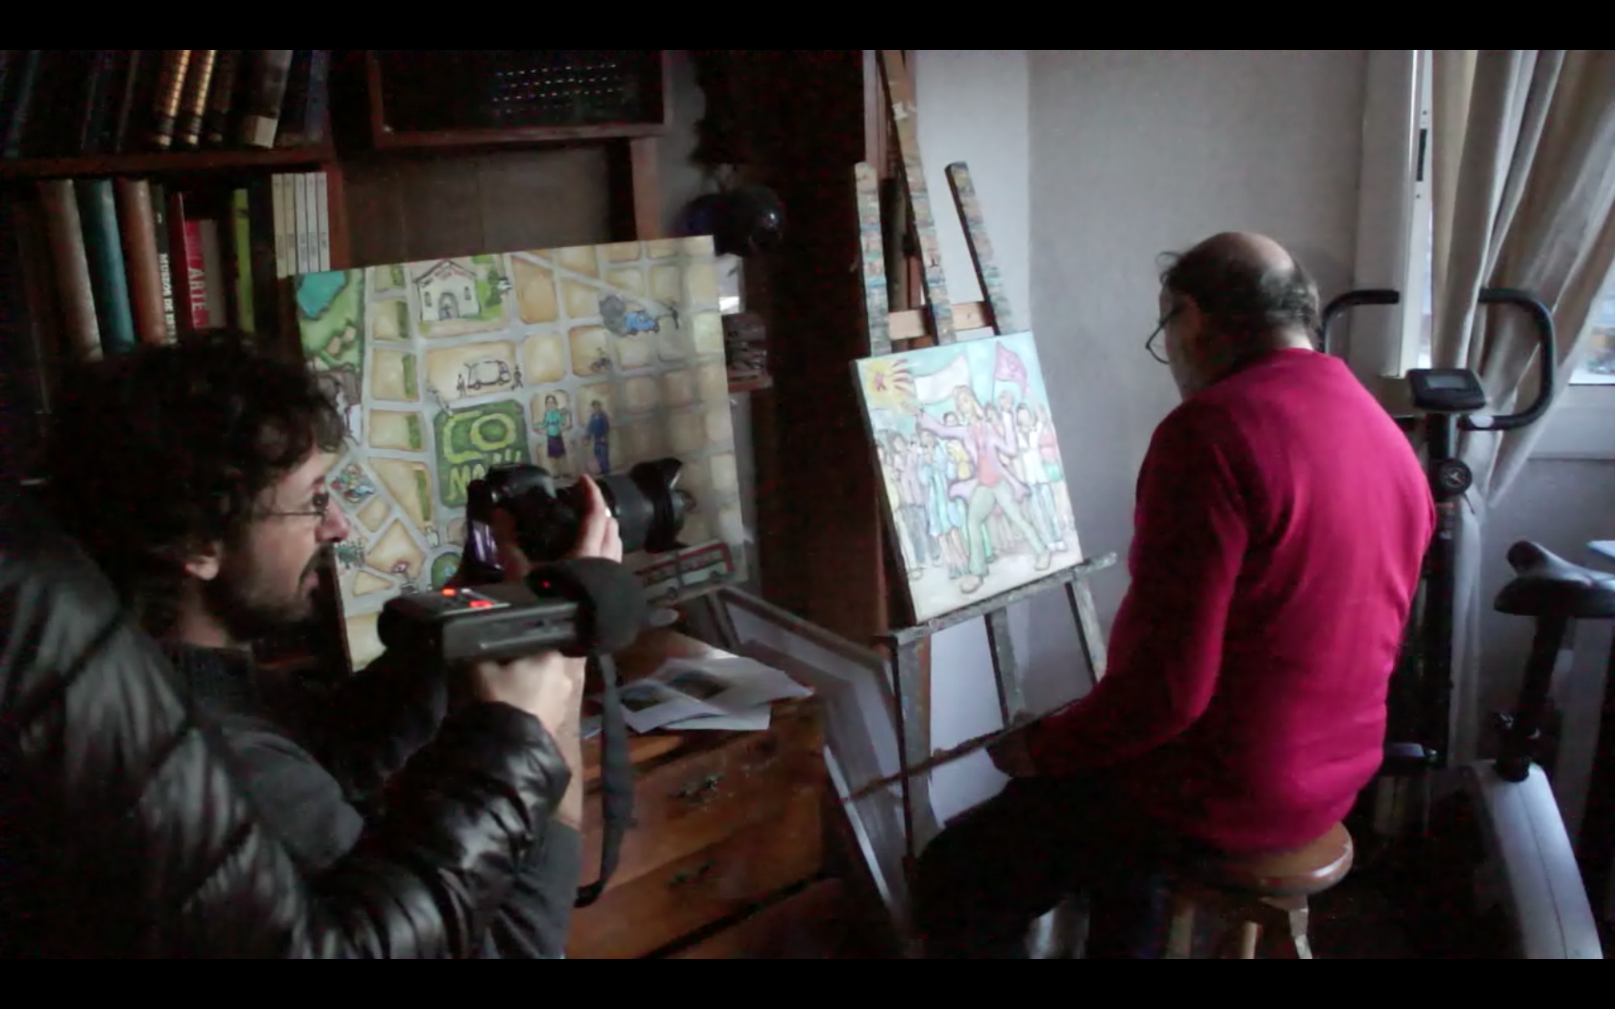
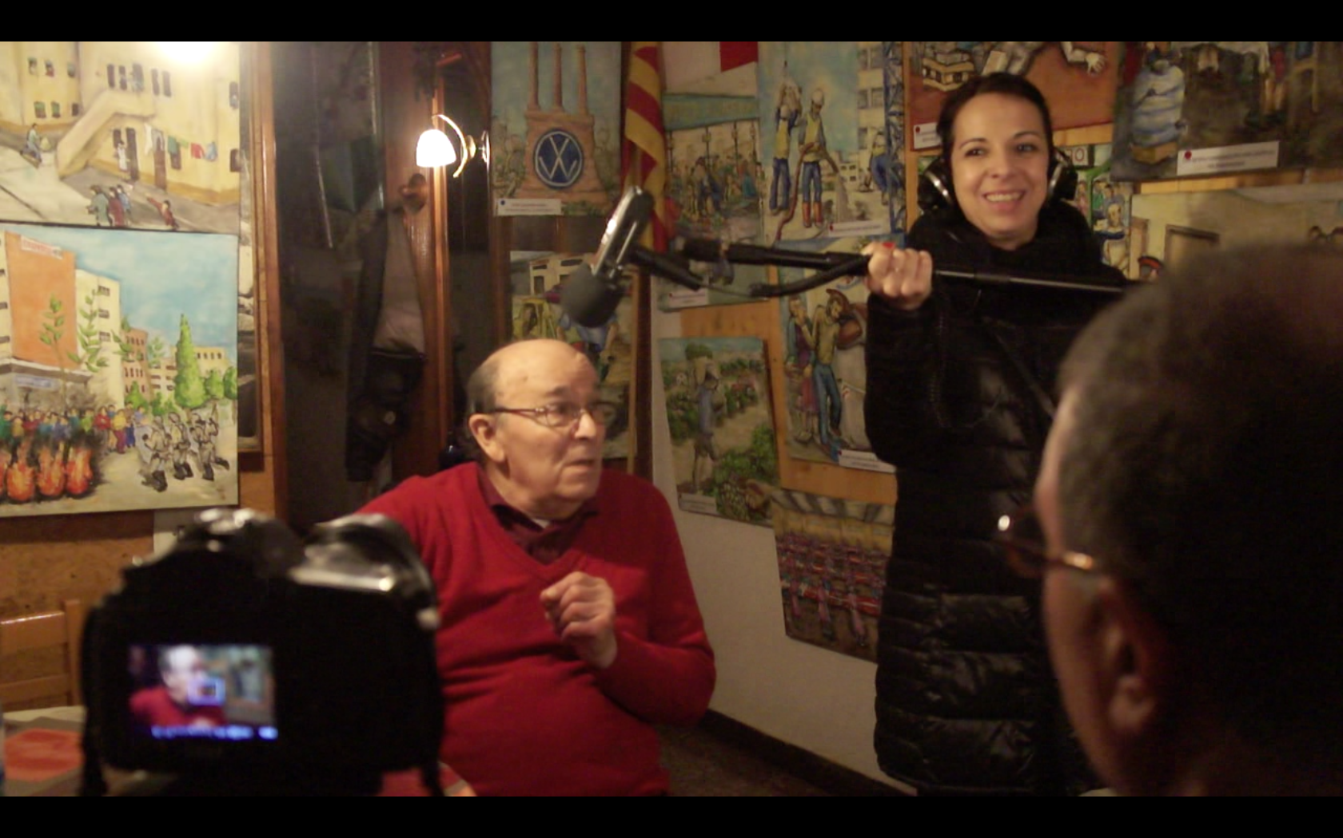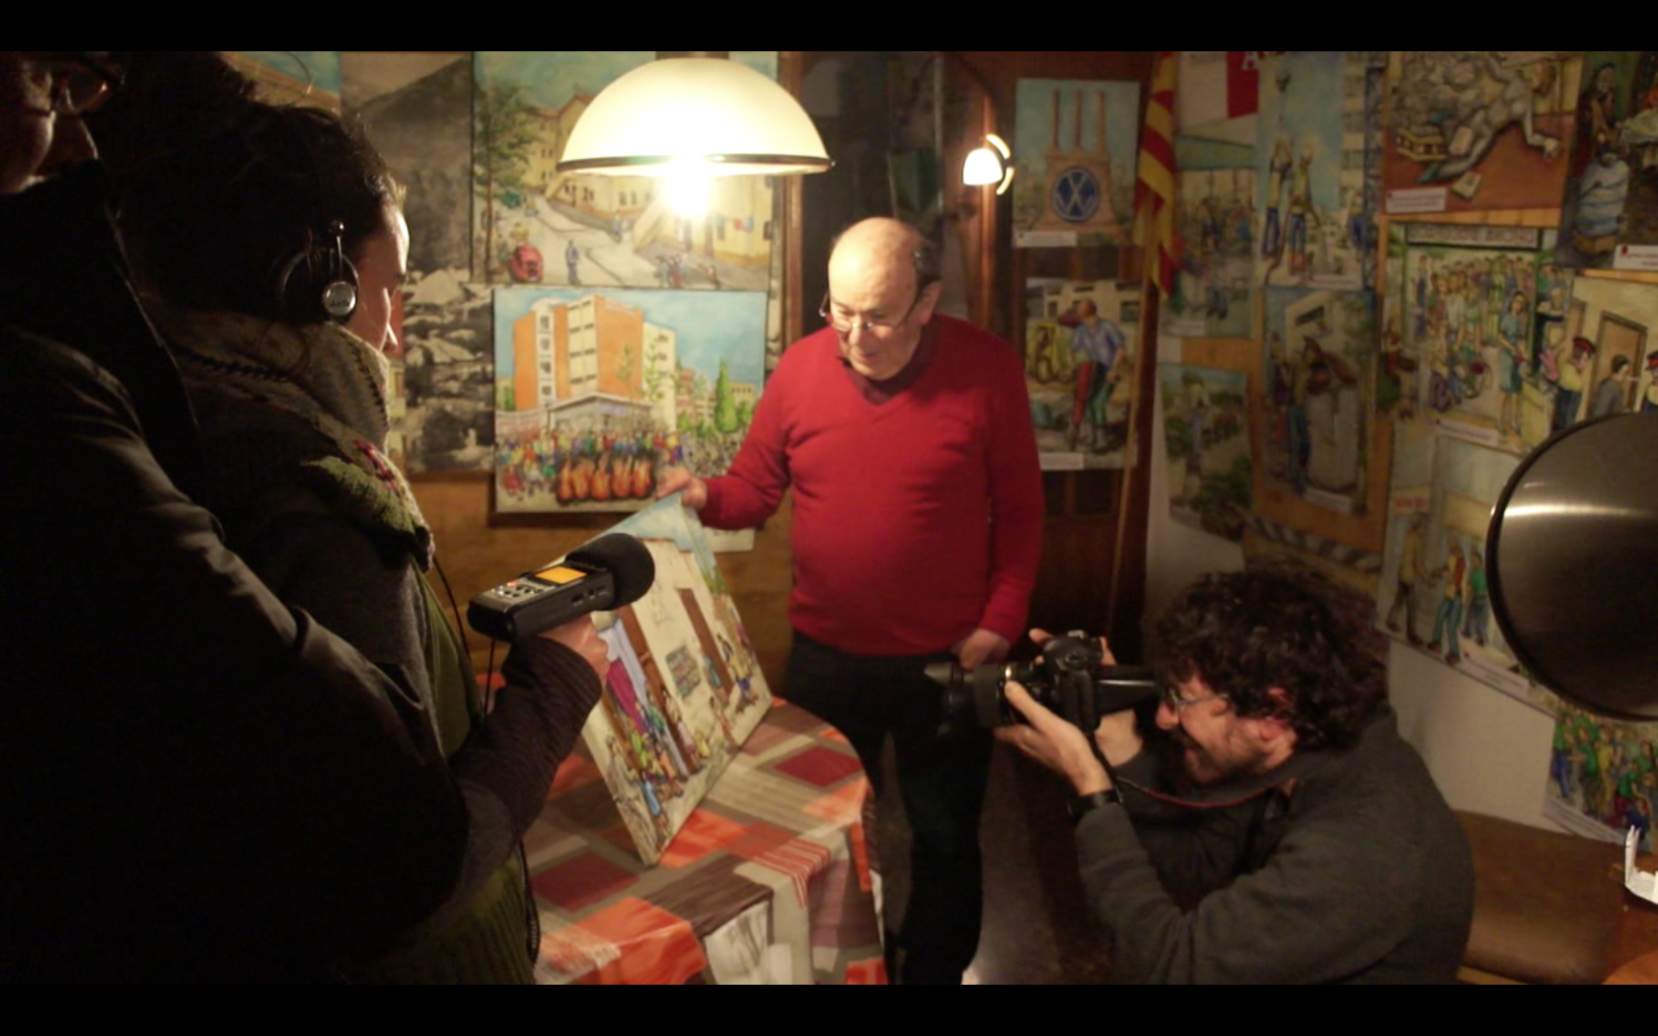

Session | 19
Date | 07/03/2017
Duration | 4h
Title | Filming
Objectives
Contents | - Recording images and sound of La Marina neighborhood  - Shooting at the Navarro's Library and at the local butcher shop
Further information | http://www.eulerproject.eu/2017/03/05/som-la-marina-activitats-marc-2017/

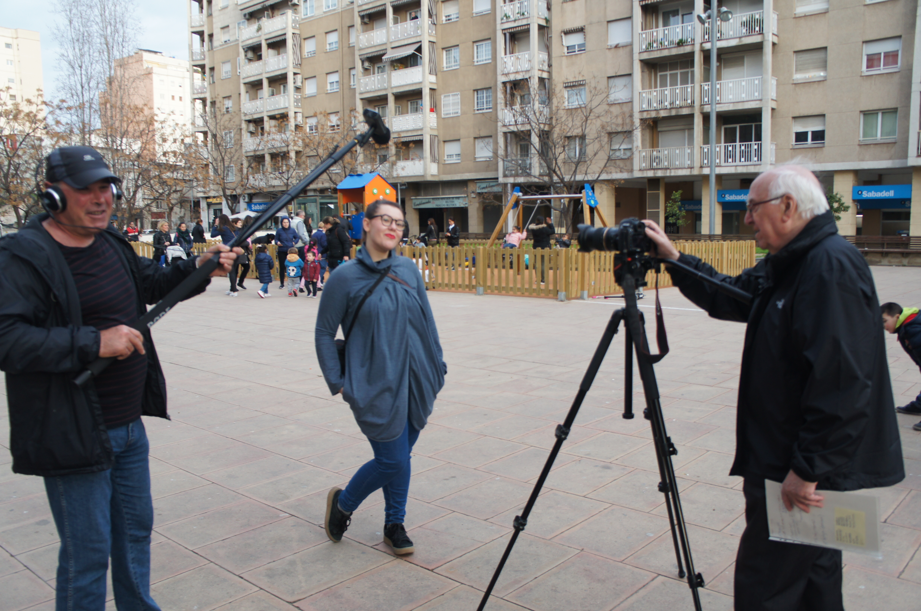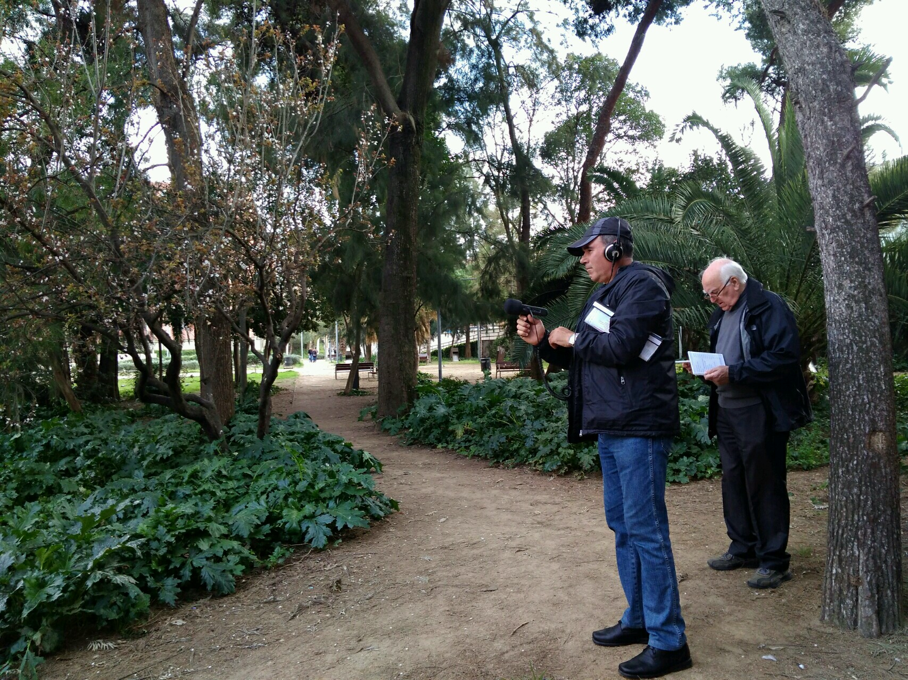
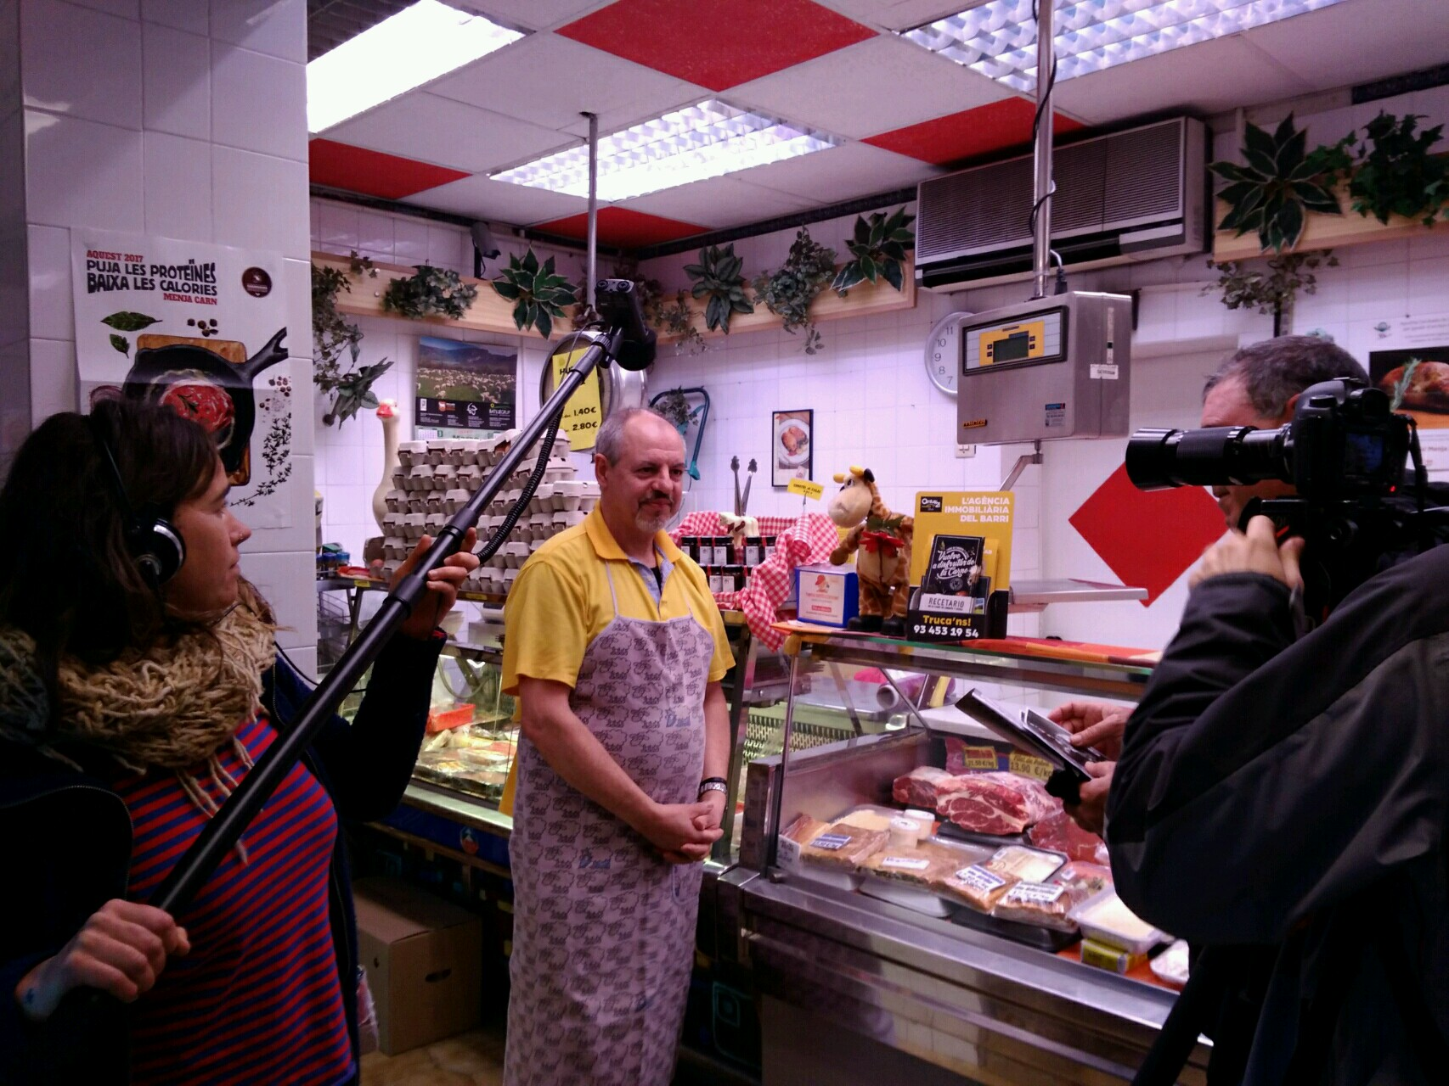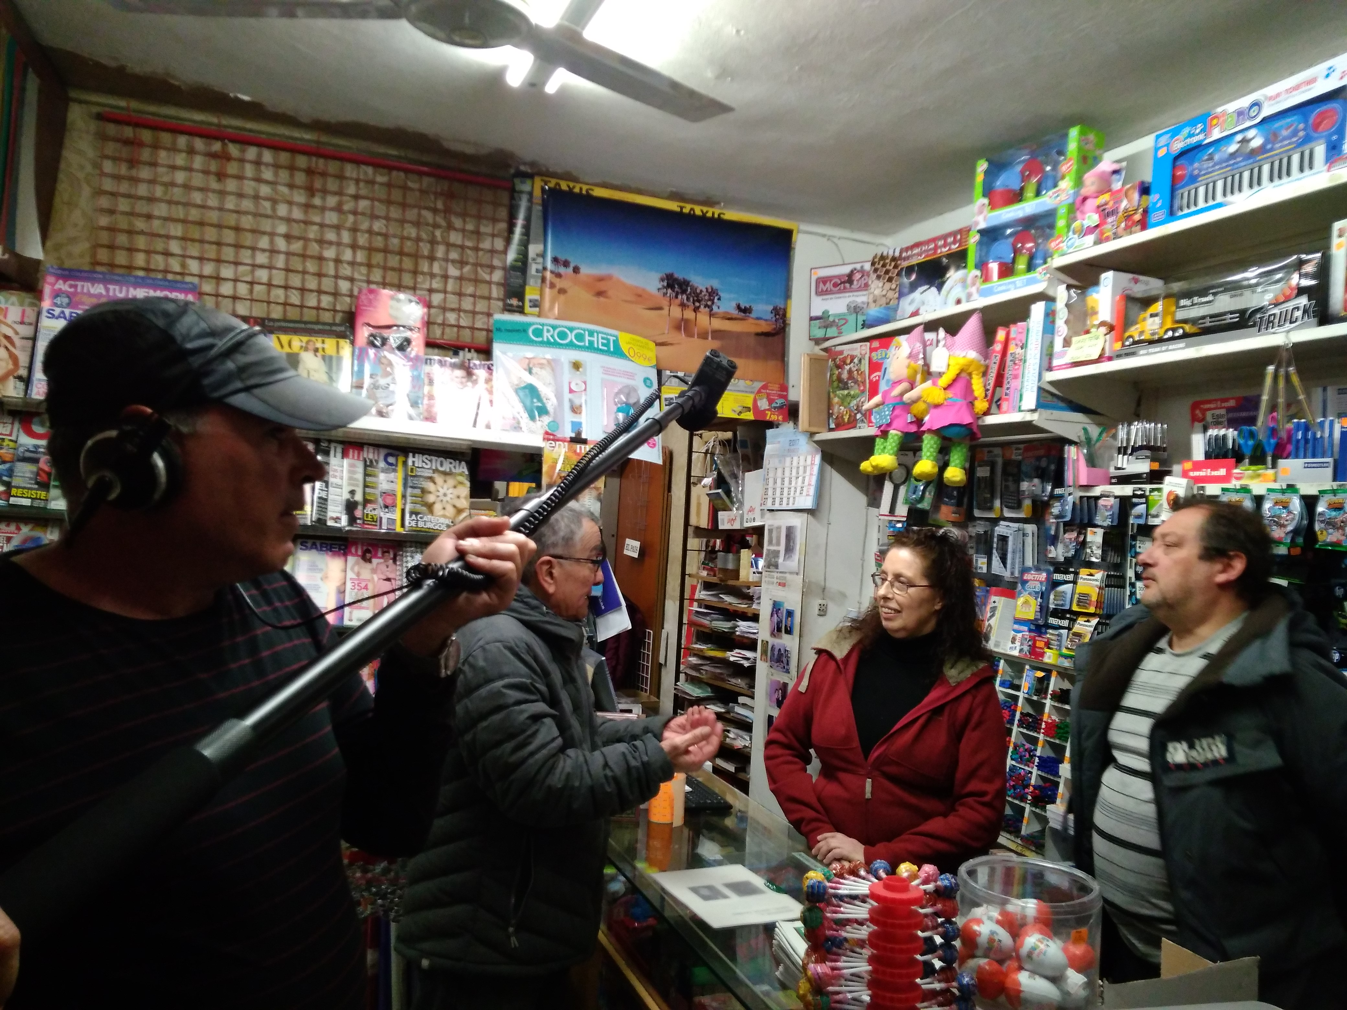

Session | 20
Date | 14/03/2017
Duration | 2h
Title | Filming and editing
Objectives
Contents | - First viewing of video results. Comments and proposals for improvement  - Decisions about editing  - Recording the interview with Josep Maria Ferrer
Further information | http://www.eulerproject.eu/2017/03/05/som-la-marina-activitats-marc-2017/

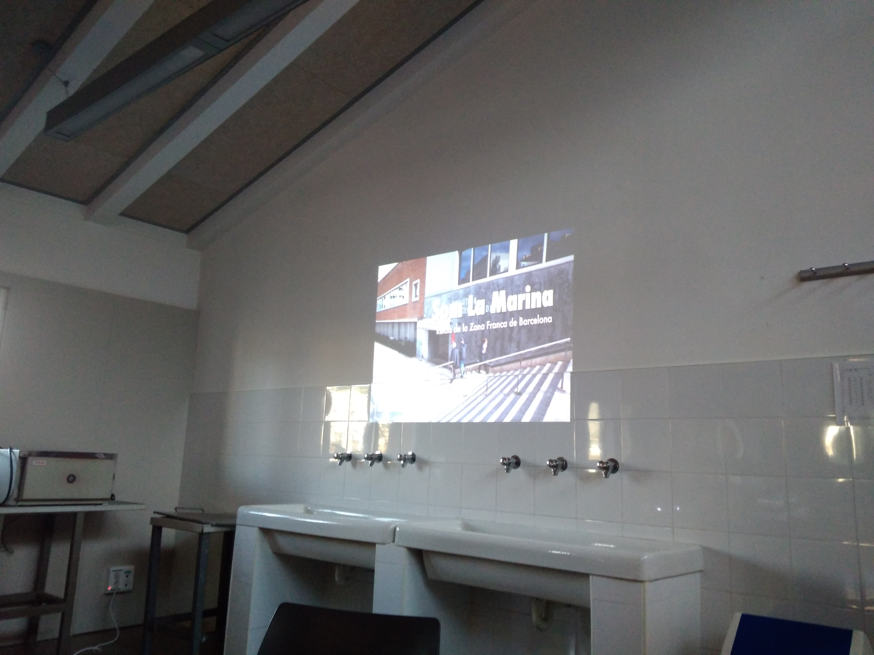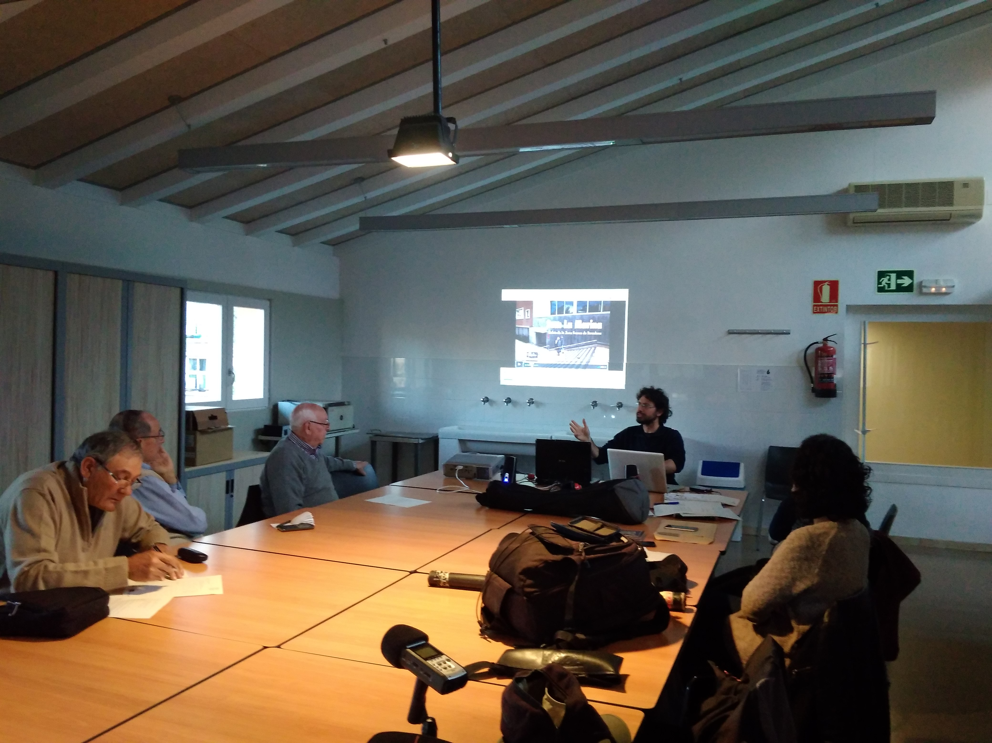
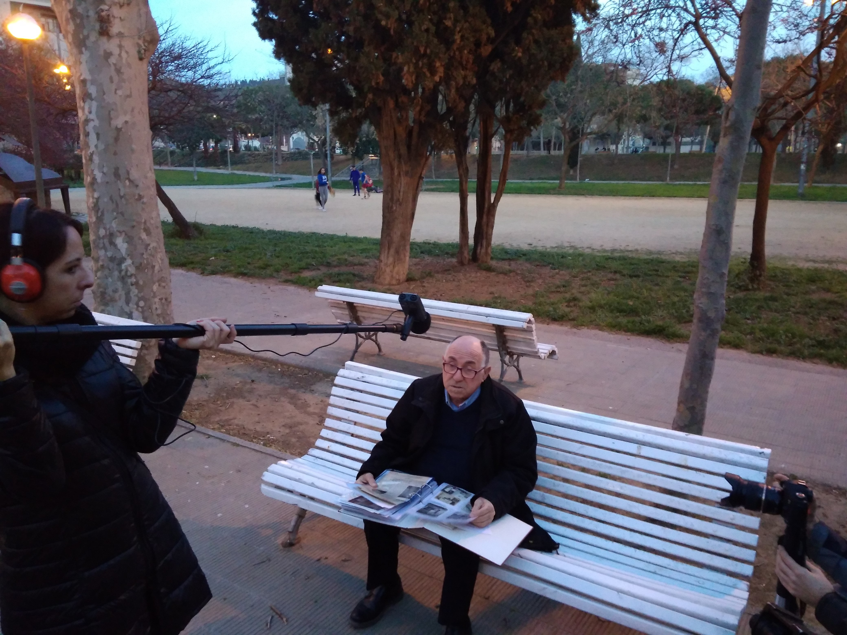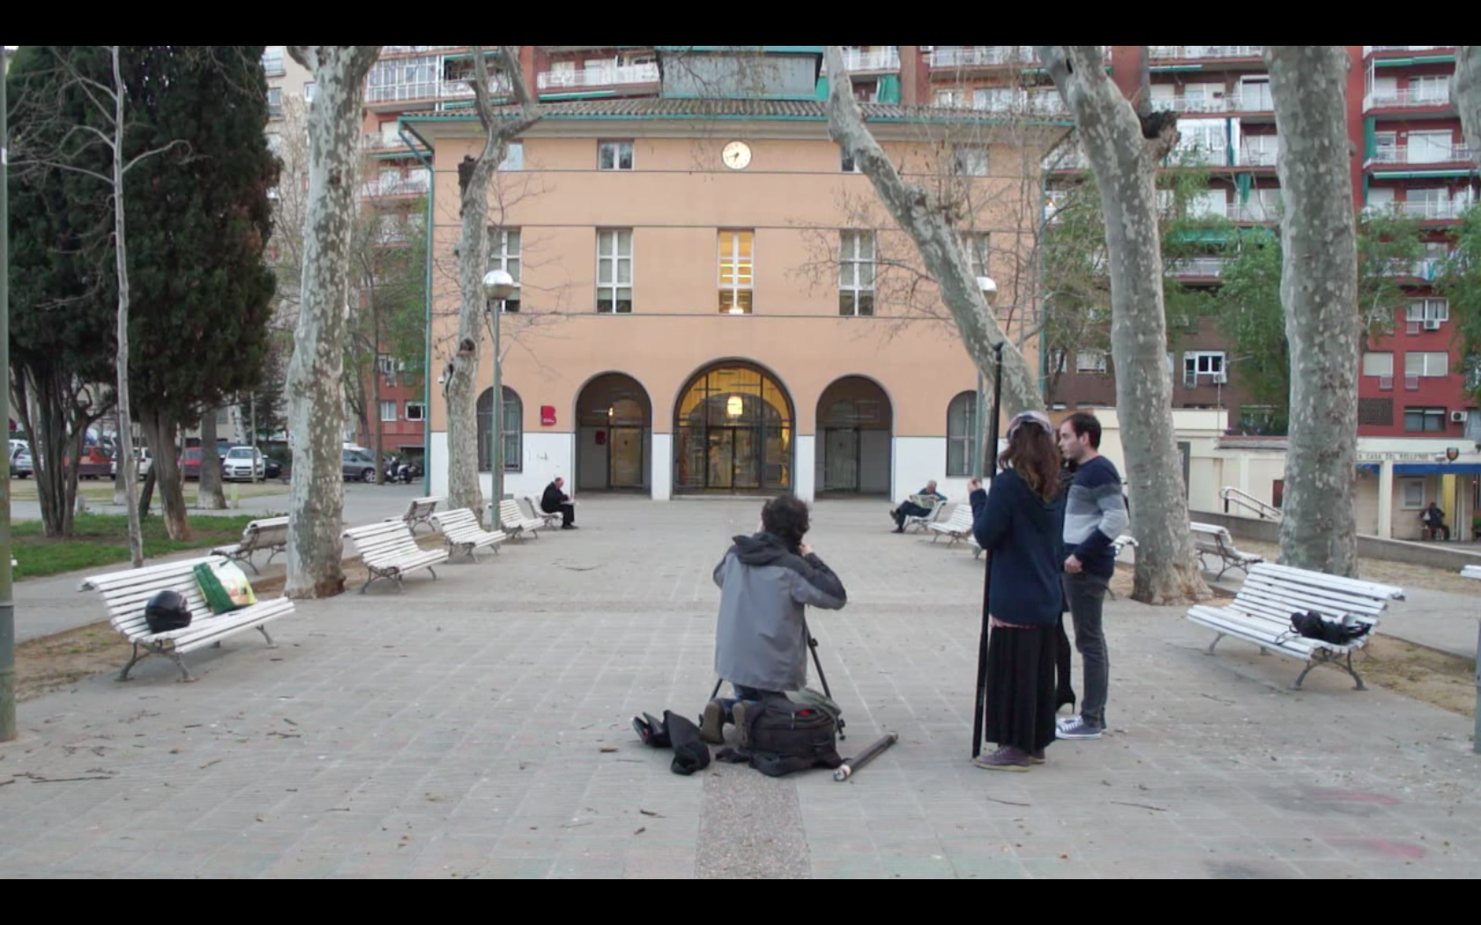

Session | 21
Date | 21/03/2017
Duration | 2h
Title | How to do a public presentation. Networking
Objectives
Contents | - Watching final videos  - Presentation of the Participative Social Documentary Platform from La Virreina (Jacobo Sucari)  - Methodologies for audiovisuals presentation in public and debates moderation techniques (by Julio Lamaña, Catalan Federation of Cineclubs)
Further information | http://www.eulerproject.eu/2017/03/05/som-la-marina-activitats-marc-2017/

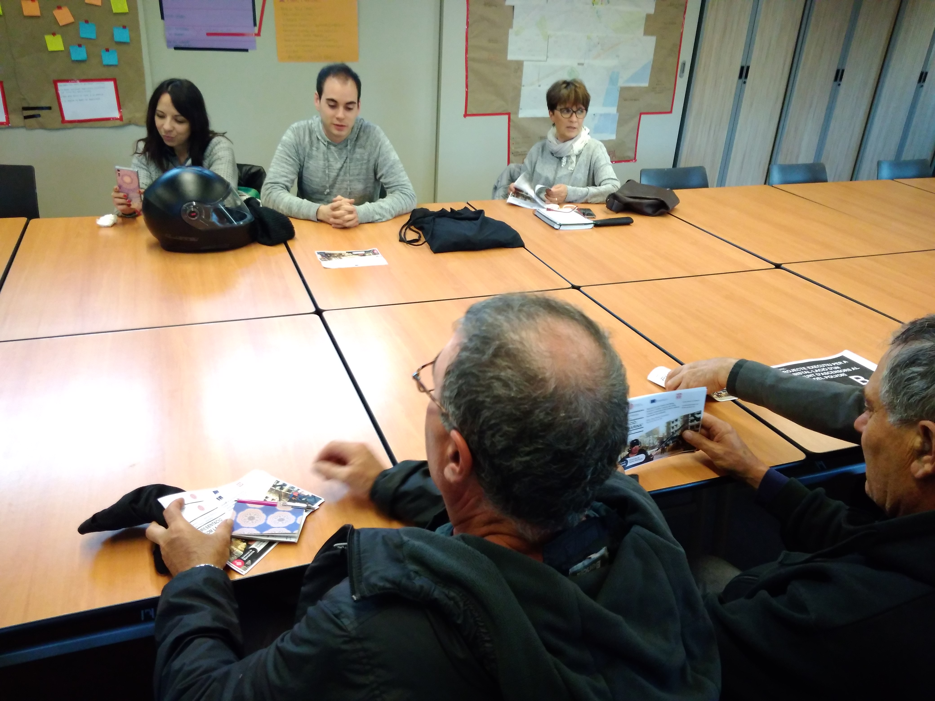

Session | 22
Date | 28/03/2017
Duration | 2h
Title | Organize public presentation
Objectives
Contents | - Organize the public presentation. Distribution of tasks.  - How to do communication and do the publicity for the public presentation  - Evaluation of the training  - Proposals and future projects
Further information | http://www.eulerproject.eu/2017/03/05/som-la-marina-activitats-marc-2017/

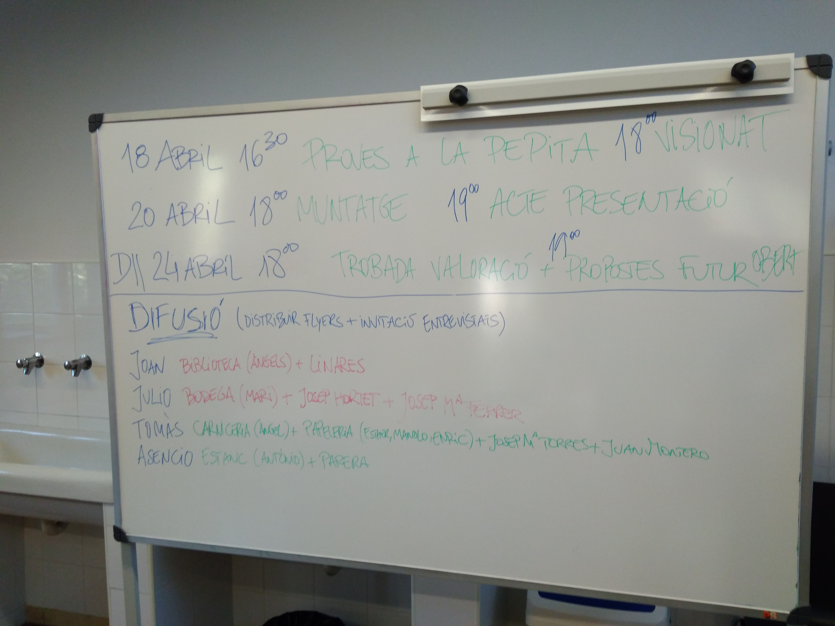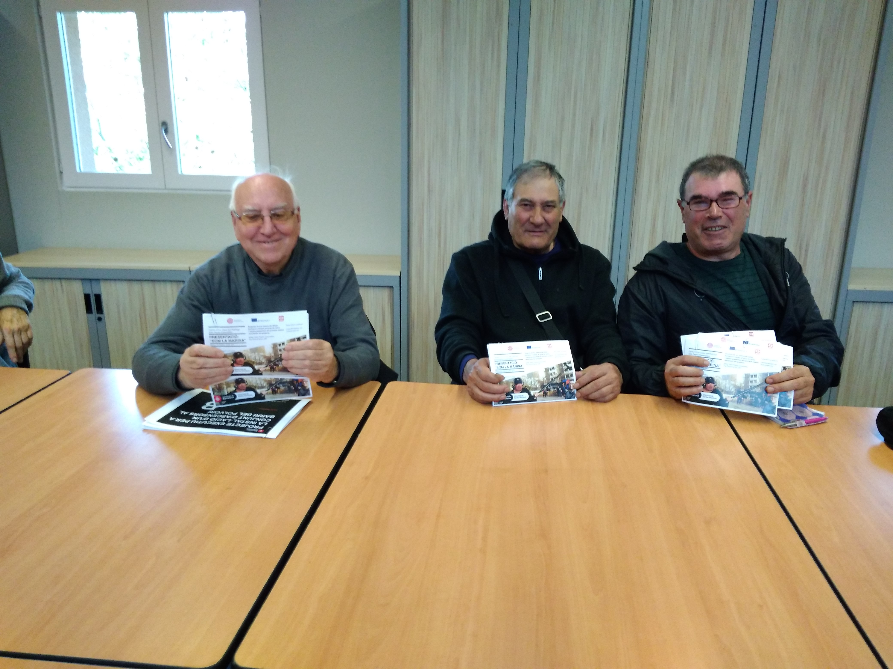
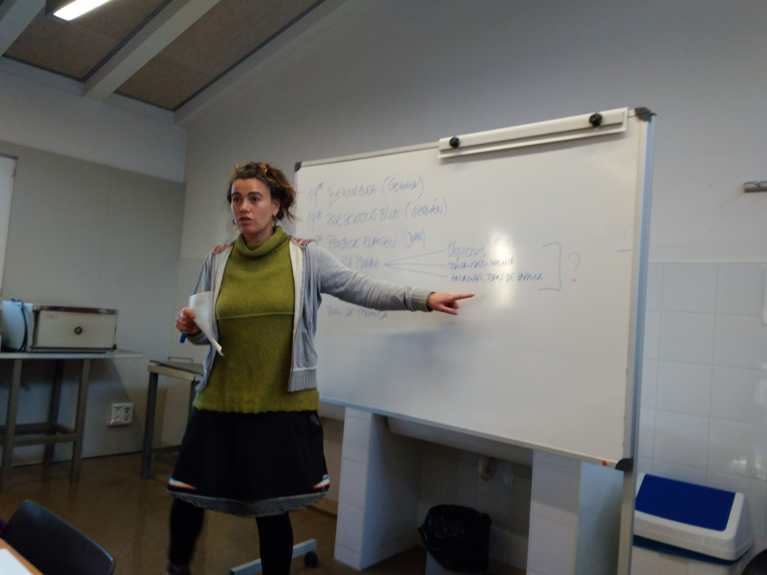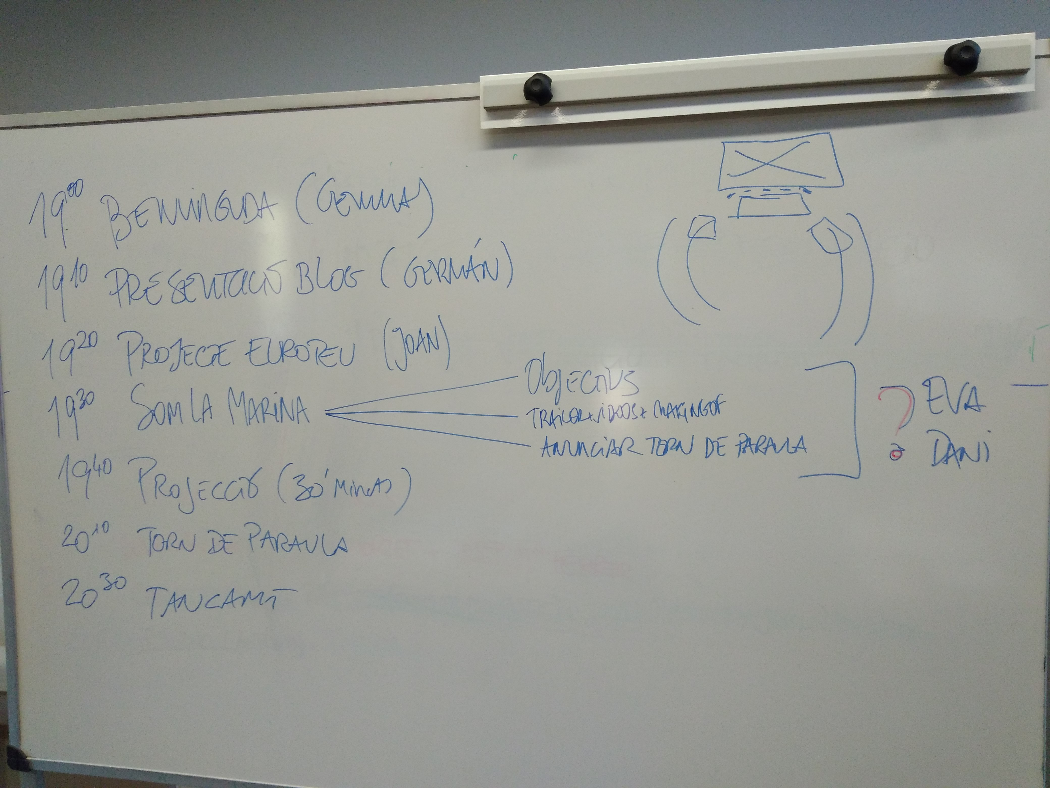

Session | 23
Date | 18/04/2017
Duration | 2h
Title | Organize public presentation
Objectives
Contents | - Testing image and sound at the auditorium  - Review of the public presentation  - Watching final videos
Further information | http://www.eulerproject.eu/2017/03/26/som-la-marina-presentacio-som-la-marina/

